**DEPARTMENT OF COMPUTER SCIENCE**

**SURANA COLLEGE**



A PROJECT REPORT ON

**KRISHI MANDALA**

WHICH IS BONAFIDE WORK OF

SANGEETHA S [19KXSB7085]

SHREYAS G BHARADWAJ [19KXSB7094]

Students of Bachelor of Computer Science submitted in partial fulfillment of the requirement of the award of

DEGREE IN B.C.A prescribed by BANGLORE UNIVERSITY 2021-2022

Mrs. RASHMI ESHWAR Dr. A SRINIVAS

(PROJECT GUIDE) HOD (COMPUTER SCIENCE)

EXAMINAR: _____________ __________________

**DEPARTMENT OF COMPUTER SCIENCE**

**SURANA COLLEGE**



A PROJECT REPORT ON

**KRISHI MANDALA**

WHICH IS BONAFIDE WORK OF

SANGEETHA S [19KXSB7085]

SHREYAS G BHARADWAJ [19KXSB7094]

**Student of Bachelor of Computer Applications**

Submitted in partial fulfillment of the requirement of the completion of

DEGREE IN

BACHELOR OF COMPUTER APPLICATIONS

Under the guidance of

Mrs. RASHMI ESHWAR

(Asst. Prof)

DEPARTMENT OF COMPUTER SCIENCE

**INDEX**

|  |  |  |
| --- | --- | --- |
| **SL.NO** | **CONTENT** | **PG.NO** |
| 1 | Acknowledgement | 3 |
| 2 | Project Synopsis | 4 |
| 3 | Feasibility Report | 7 |
| 4 | Introduction To DBMS | 8 |
| 5 | Introduction To Python | 11 |
| 6 | Requirement Analysis | 14 |
| 7 | SRS Document | 18 |
| 8 | System Design | 24 |
| 9 | DataFlow Diagram | 26 |
| 10 | Entity Relationship diagram | 31 |
| 11 | System Implementation  (With Source Code) | 33 |
| 12 | Testing | 65 |
| 13 | Sample Out | 68 |
| 14 | Front End Source Code | 91 |
| 15 | Future Enhancement And Conclusion | 102 |
| 16 | Bibliography | 103 |

**ACKNOWLEDGEMENT**

The successful completion of any work would be always incomplete unless we mention the valuable cooperation and assistance of those people who were a source of constant guidance and encouragement. The growth and completion of this project has been quite challenging and has been done with sincere effort.

It is not possible to develop a project and prepare a project report without the assistance and encouragement of many. We make use of this opportunity to thank all those who helped us in bringing out this project.

We would like to express our gratitude to **Dr Bhavani M R** honorable principal, for giving us all the facilities for the completion of our project. We would like to express our gratitude to **Dr Srinivas A** (Head of Computer Science Department) for granting us permission to carry out this project work at college.

We sincerely thank our guide **Mrs. Rashmi Eshwar** and all teachers for their constant help for our project. A special thanks to **Mr. Mahendra** for his complete support and guidance. We also thank to all our family and friends for their valuable suggestions and encouragement.

**PROJECT SYNOPSIS**

**OVERVIEW:**

Krishi Mandala is based on web-based application and it has been developed using python and sqlite. The objective of this project is to connect farmers with customers. Also to upload and maintain data of users and farmers with a content management system that would allow crops information to be updated securely. The web portal will have an online interface in the form of a content management system that will allow farmers to sell their crops, fruits, vegetables; admin to manage reports of crops, seeds, fertilizers; bloggers and farmers details, customer database and reporting of the sales, orders.

The Krishi Mandala website will have an E-commerce features that will allow users to order crops, check crops price dynamically and also view static data, payments, order tracking and they can gather information regarding crops by blogging.

**PROBLEM STATEMENT:**

India is an agricultural country with around 70% of its people depending directly or indirectly upon agriculture. The number of farmers who are committing suicide day by day is increasing.

The indebtedness of farmers is one of the main reasons driving them to commit suicide. Farmers will not get sufficient money for what they sell. This is because of many individuals who is responsible for transporting products from farmers to customers. Crop fluctuations may lead to confusion to farmers to grow the particular crop.

**OBJECTIVE:**

The main objective of this project is to connect farmers directly with their customers.

This may help farmers to get sufficient money without any intermediates. And also helps customers to get fresh products and at low price directly from farmers.

Static data visualization helps farmers to predict the price of a particular crop from previous year and also helps farmers to grow crops more efficiently with the help of information (videos, blogs) provided.

**COMPONENTS:**

This project will be divided into following separate components:

* The content management system
* The e-commerce website/portal
* The crops, fruits, vegetables, fertilizers, seeds, farmer, customer and blogger database
* Reporting of the sales, orders, data visualisation
* The data security system.

**MODULAR DESCRIPTION:**

These are the main modules of the project:

* **Products Module**:

-Product module includes various categories namely crops, fruits, vegetables, seeds and fertilizer.

-Farmers will add crops, fruits and vegetables according to their convenience and price.

-User can buy the products uploaded by the farmers.

* **Farmers Module:**

-Farmers will add their crops/fruits/vegetables which they have to sell.

-It is not directly added to the product module until the admin verifies it.

-Farmers have access on Newsfeed and data visualization module which help them to grow their crops effectively.

-Farmers should first register and login to the website to get access.

* **Customers Module**:

-Customers will buy the products which was added by the farmers.

-Customers can buy the products from various categories at once and add it to the cart.

-The order will be confirmed once they give confirm order.

-They should first register and login to get access to buy the products.

* **Blogger Module:**

-Blogger can write their blogs which will be added to the Newsfeed module.

-Blogger can also edit their blogs if needed.

-They should first register and login to get access to write blogs.

* **Admin Module:**

**-**Admin have all access to modify or to delete the products (crops, fruits, vegetables) added by the farmers.

**-**Admin can also modify and delete the blogs written by the bloggers.

**-**Admin can see the graph of the crops and their prices.

**FEASIBILITY REPORT**

**Technical Feasibility Study**

The system technically feasible because here we are using Python and sqlite database which is free to use for educational purposes. From the user’s point of view, it is feasible because it can fulfill user's requirements and maintain their records.

**Operational Feasibility Study**

Operational Feasibility is the measure of how well the proposed system solves the problem and specifies the requirements in the system development. degree of providing service to requirements is analyzed along with how much easy product will be to operate and maintenance after deployment.

This application is feasible as this as this system can be implemented in the organization there is adequate support from the management and users. Being developed in python so that the necessary operations are carried out automatically and it is user friendly.

**Economic Feasibility Study**

Economic Feasibility study cost and benefit of the project is analyzed. Means under this feasibility study a detail analysis is carried out what will be cost of the project for development which includes all required cost for final development like hardware and software resource required, design and development cost and operational cost and so on.

**INTRODUCTION TO DBMS**

The database is a collection of inter-related data which is used to retrieve, insert and delete the data efficiently. It is also used to organize the data in the form of a table, schema, views, and reports, etc.

For example: The college Database organizes the data about the admin, staff, students and faculty etc.

**Advantages:**

* Controls database redundancy
* Data sharing
* Easy Maintenance
* Reduce time
* Multiple user interface

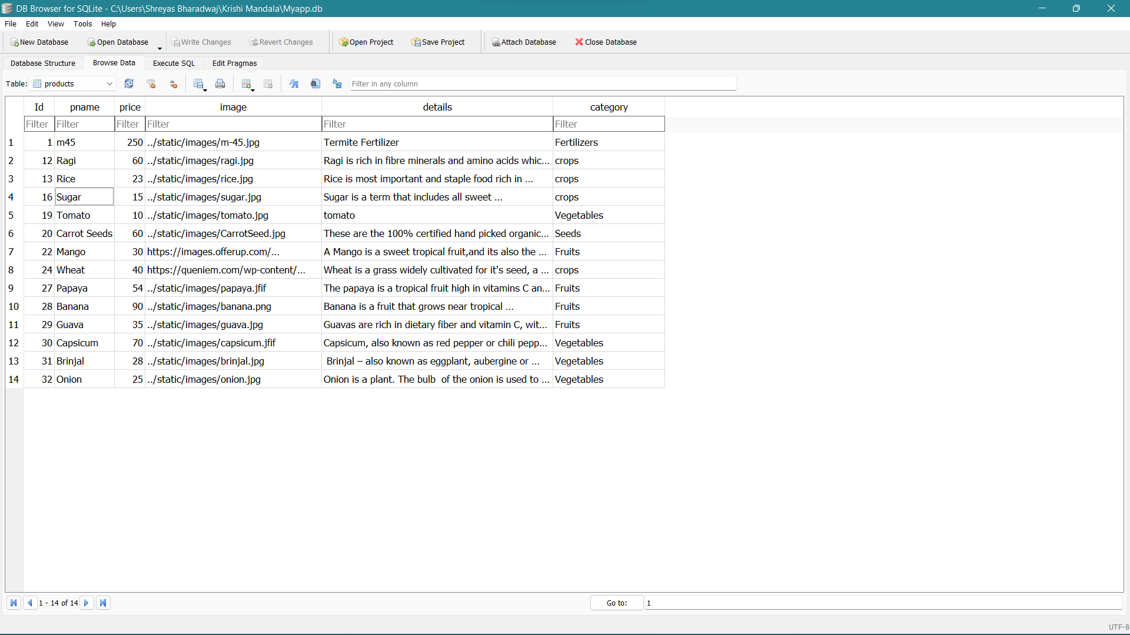

**INTRODUCTION TO RDBMS**

Relational database is most commonly used database. It contains number of tables and each table has its own primary key.

Due to a collection of organized set of tables, data can be accessed easily in RDBMS.

In a relational database, each row in the table is a record with a unique ID called the key. The columns of the table hold attributes of the data, and each record usually has a value for each attribute, making it easy to establish the relationships among data points.

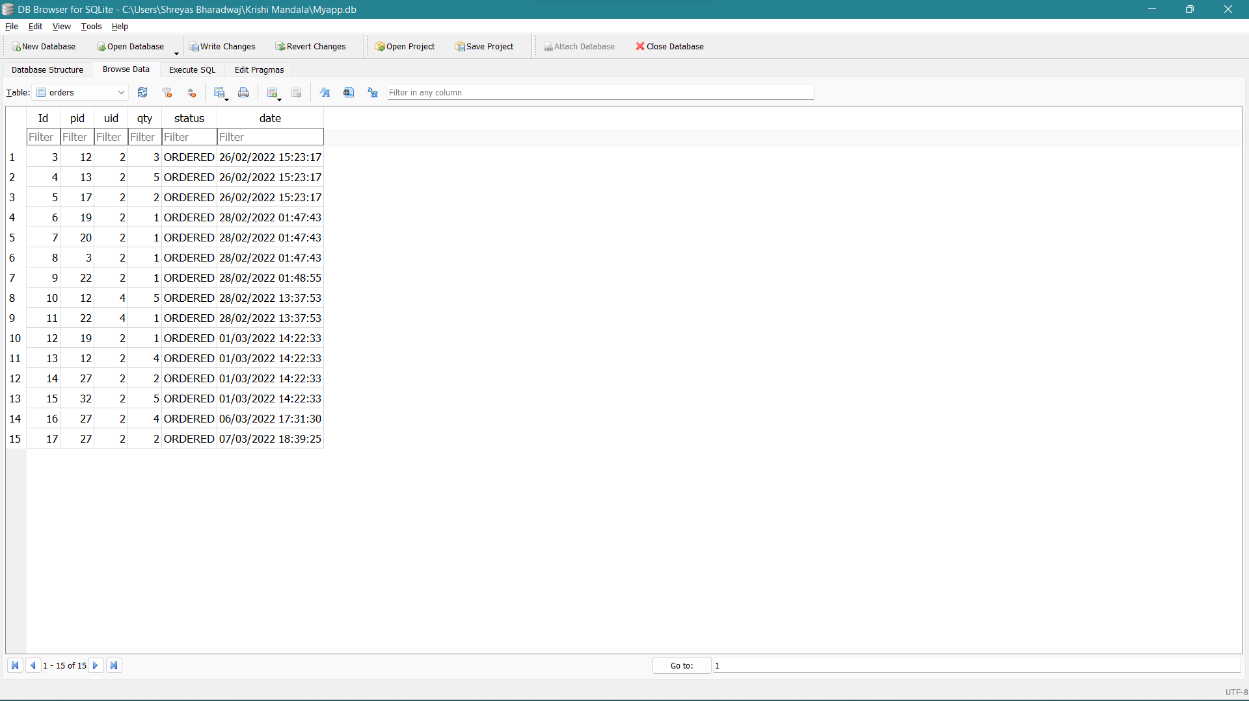

**NORMALIZATION**

Normalization is the process of organizing the data in the database.

Normalization is used to minimize the redundancy from a relation or set of relations. It is also used to eliminate the undesirable characteristics like Insertion, Update and Deletion Anomalies.

Normalization divides the larger table into the smaller table and links them using relationship.

The normal form is used to reduce redundancy from the database table

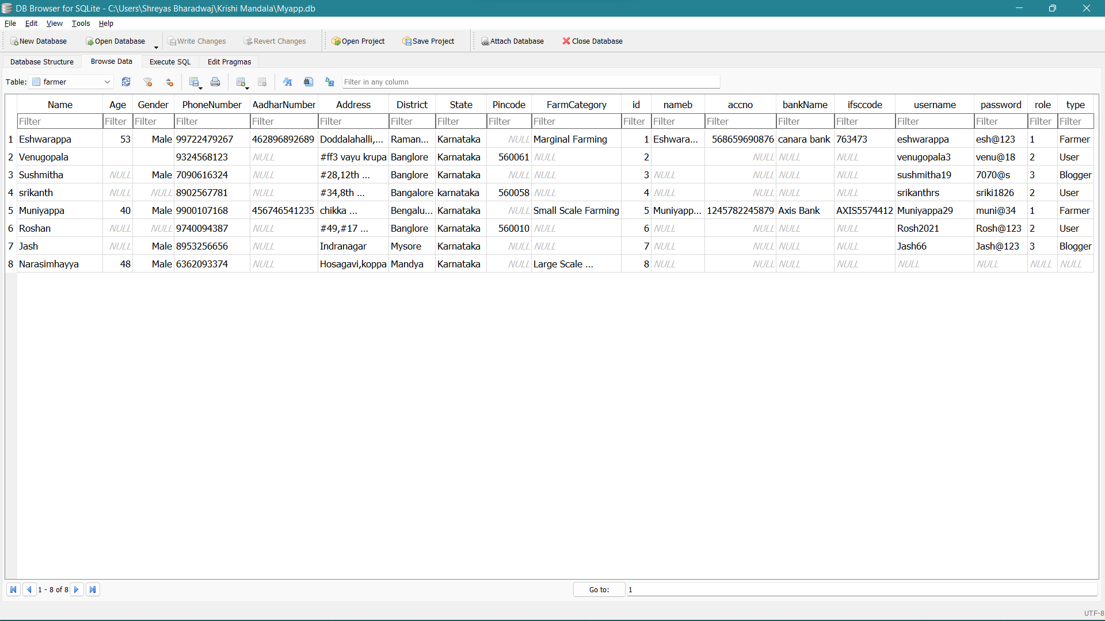

**INTRODUCTION TO PYTHON**

Python was created by Guido van Rossum, and released in 1991.Python is an interpreted, object-oriented, high-level programming language with dynamic semantics. Its high-level built-in data structures, combined with dynamic typing and dynamic binding, make it very attractive for Rapid Application Development, as well as for use as a scripting or glue language to connect existing components together. Python's simple, easy to learn syntax emphasizes readability and therefore reduces the cost of program maintenance. Python supports modules and packages, which encourages program modularity and code reuse. The Python interpreter and the extensive standard library are available in source or binary form without charge for all major platforms, and can be freely distributed.

**Features of Python**

1.Easy to Learn and Use: Python is easy to learn as compared to other programming languages. Its syntax is straightforward and much the same as the English language.

2. Interpreted Language: Python is an interpreted language; it means the Python program is executed one line at a time. The advantage of being interpreted language, it makes debugging easy and portable.

3. Free and Open Source: Python is freely available for everyone. The open-source means, "Anyone can download its source code without paying money.

4. Object-Oriented Language: Python supports object-oriented language and concepts of classes and objects come into existence. It supports inheritance, polymorphism, and encapsulation, etc.

5. Extensible: It implies that other languages such as C/C++ can be used to compile the code and thus it can be used further in our Python code. It converts the program into byte code, and any platform can use that byte code.

6. Large Standard Library: It provides a vast range of libraries for the various fields such as machine learning, web developer, and also for the scripting

7. GUI Programming Support: Graphical User Interface is used for the developing Desktop application.

**WHY PYTHON?**

*Python is an interpreted, object-oriented, high-level programming language with dynamic semantics.

*Python is compatible with different platforms like Windows, Mac, Linux, Raspberry Pi, etc.

*Python has a simple syntax as compared to other languages.

*Python allows a developer to write programs with fewer lines than some other programming languages.

* Python runs on an interpreter system, means that the code can be executed as soon as it is written. It helps to provide a prototype very quickly.

*Python can be described as a procedural way, an object-orientated way or a functional way.

*The Python interpreter and the extensive standard library are available in source or binary form without charge for all major platforms, and can be freely distributed

The following are some reasons why Python is an ideal language to create websites.

* The vast collection of libraries
* Relatively easier to learn
* Budget-friendly
* Excellent data visualization capabilities
* Secure and scalable

REQUIREMENT ANALYSIS

All possible requirements of the system to be developed and captured in this phase. Requirements are a set of functions and constraints that the end user expects from the system. The requirements gathered from the end user at the start of the software development phase. These requirements are analyzed for their validity, and the possibility of incorporating the requirements in the system to be developed is also studied. Finally, a requirement specification document is created which serves the purpose of guideline for the next phase of the model.

Requirements Analysis is the process of defining the expectations of the users that is to be built or modified. It involves all the tasks that are conducted to identify the needs of different stakeholders. Therefore, requirements analysis means to analyze, document, validate and manage software or system requirements.

Requirements are descriptions of the services that a software system must provide and the constraints under which it must operate. Requirements can range from high-level abstract statements of services or system constraints to detailed mathematical functions specifications.

Requirement may serve a dual function:

*May be the basis of for a bid for a contract- therefore must be open to interpretation

*May be the basis for the contract itself-therefore must be defined in detail

Both the statements may be called requirements.

**REQUIREMENTS**

Requirement analysis phase is divided into:

* Hardware Requirements
* Software Requirements
* Functional Requirements
* Non-Functional Requirements

**Hardware Requirements:**

These requirements include the **minimum processor speed, memory, and disk space required to install Windows.** There is no rigorous restrictions on the machine configuration. The model should be capable of working on all machines capable of supporting recent versions of any version of Windows operating system.

* **Processor:** Pentium V, 2.1GHz and above.
* **RAM:** 4GB (minimum) or 8GB (recommended).
* **Hard disk:** 80GB or above.
* **Monitor:** 15” CRT or LCD monitor.
* **Keyboard:** Normal or Multimedia
* **Mouse:** Any compatible mouse.

**Software Requirements:**

The software requirements are description of features and functionalities of the target system. Requirements convey the expectations of users from the software product. The requirements can be obvious or hidden, known or unknown, expected or unexpected from client’s point of view.

* **Operating System**: Windows 7 Or More.
* **Front End:** Bootstrap CSS 5
* **Database:** Db Browser sqlite3
* **Back End:** Python
* **Tools:** Visual studiocodeEditor2019, Git Bash.

**Functional Requirements:**

Functional requirements capture the intended behavior of the system. This behavior may be expressed as services, tasks or functions the system is required to perform. It specifies actions that a system must be able to perform, without taking physical constraints into consideration. Functional requirements the specify the input and output behavior of a system.

* I**ntended Audience:**
* Farmer- Personal details, bank details. Sell products (crops, fruits, vegetables).
* User- Personal details, order details
* Blogger- Personal details, uploading or editing blogs.
* Product’s behaviour is considered in data visualization.
* Information is provided in form of blogs, videos and schemes.

**Non-Functional Requirements:**

A Non-functional requirement is a statement of how a system must behave; it is a constraint upon the systems behavior. Non-functional requirements specify all the remaining requirements not covered by the functional requirements. They specify criteria that judge the operation of a system, rather than specific behaviors.

* Accuracy: The system should perform it’s process in accuracy.
* Modifiability: The system should be easy to modify.
* Security: The system should be secure and saving student’s privacy.
* Usability: The system should be easy to deal with and simple to understand.
* Maintainability: The maintenance group should be able to fix any problem occur suddenly.
* Speed and responsiveness: Execution of operation should be fast.

Here are the main activities involve in requirement analysis:

* + Identify customer's needs.
  + Evaluate system for feasibility.
  + Perform economic and technical analysis.
  + Allocate functions to system elements.
  + Establish schedule and constraints.
  + Create system definitions.

**Software Requirement Specification (SRS) Document**

SRS document is a contract between the development team and the customer. Once the SRS document is approved by the customer, any subsequent controversies are settled by referring the SRS document. This should be carefully written.

* It is a formal and official document.
* It resolves the conflict between user and developer.
* Based on SRS, further development of the system takes place.
* It is the fundamental document, bridges the gap between user requirements and developers view.

IEEE standard suggests the following structure for requirements documents:

**1.Introduction**

**1.1 Purpose of the Requirements Document.**

The purpose of this document is to unambiguously specify the software requirements for a web-based application KRISHI MANDALA providing disseminated information on farming and bring awareness to farmers to grow their crops efficiently. This project connects farmers directly with their customers. This may help farmers to get sufficient money without any intermediates. And also helps customers to get fresh products and at low price directly from farmers.

* + 1. Intended Audience

The Intended Audience for this project can be broadly classified under four main categories, these are: 1.Farmers

2.Customers

3.Bloggers

**1.2 Scope of the product**

The scope of this document is to identify the software requirement specifications relating to the trading, where farmers sells their products and customers can buy the products. The project would focus on enabling static data visualization which helps farmers to predict the price of a particular crop from previous year and also helps farmers to grow crops more efficiently with the help of information (videos, blogs) provided.

**1.3 Definitions, acronyms and abbreviations**

|  |  |
| --- | --- |
| **Terms** | **Definition** |
| Python | Python is an interpreted, high-level and general-purpose programming language. |
| Visual Studio Code | Visual Studio Code can be classed as an integrated development environment (IDE), meaning that developers can write and test code at the same time. |
| dB Browser sqlite3 | DB Browser for SQLite is a high quality, visual, open-source tool made for creating, designing, and editing database files that are compatible with SQLite |

|  |  |
| --- | --- |
| **Terms** | **Definition** |
| SRS | Software Requirement Specifications |
| ER Diagram | Entity-Relationship Diagram |
| DFD | Data Flow Diagram |
| HTML | Hyper Text Markup Language |
| OS | Operating System |

**1.4 References**

<https://agricoop.nic.in/sites/default/files/CAPSRSVer1.0.pdf>

**1.5 Overview of remainder of the document**

* The next chapter, the general description section of this document gives an overview of the functionality of the product.
* The third chapter describes External Interface Requirements that are hardware and software requirements.
* The fourth and fifth chapters, Specific Requirements section of this document is written primarily for the developers and describes in technical terms, the details of the interfaces, functional and non-functional requirements of the system.

**2. General Description**

**2.1 Product perspective**

Krishi Mandala will be a generic and Open Source software that captures the information and handles database. Management processes for the uploading and trading of products generates the reports of order status.

**2.2 Product functions**

The complete data is stored in the database of personal details of farmers, users and bloggers only if they register.

This will capture the details of the sub services specified in Chapter 1 under Scope section for the specified service components.

**2.3 User characteristics**

* Admin: Admin have all access to modify or to delete the products (crops, fruits, vegetables) added by the farmers. Admin can also modify and delete the blogs written by the bloggers.
* Farmers: Farmers will add their crops/fruits/vegetables which they have to sell. Farmers have access on Newsfeed and data visualization module which help them to grow their crops effectively.
* Customers: Customers will buy the products which was added by the farmers and verified by Admin.
* Blogger: Blogger can writes their blogs which will be added to the Newsfeed module and can also edit their blogs if needed.

**2.4 General constraints**

Telegram is accessed to stay connected with farmers instead of normal text messages.

**2.5 Assumptions and dependencies**

* We assume that the computers that will use the software will be part of the college LAN.
* We assume that farmers are not able to upload image for their product.
* We assume that the Bloggers may want to edit their blogs and gave access accordingly.
* The end users of this software are assumed to have basic level of computer knowledge i.e, point and click.

**3.Specific Requirements**

**3.1 Functional Requirements**

* Intended audience

1.Farmers-

Personal details

Bank details

Sell products (crops, fruits, vegetables)

2.Customer-

Personal details

Order details

3.Blogger-

Personal details

Uploading / editing Blogs

* Products behaviour is considered in data visualization.
* Information is provided to farmers in the form of videos, blogs and schemes.
  1. **Non-functional requirements**
* Accuracy: The system should perform it’s process in accuracy.
* Modifiability: The system should be easy to modify.
* Security: The system should be secure and saving student’s privacy.
* Usability: The system should be easy to deal with and simple to understand.
* Maintainability: The maintenance group should be able to fix any problem occur suddenly.
* Speed and responsiveness: Execution of operation should be fast.
  1. **Interface requirements**
* **Hardware requirements**
* Processor: Pentium IV, 2GHz and above.
* RAM: 2GB (minimum) or 4GB (recommended).
* Hard disk: 80GB or above.
* Monitor: 15” CRT or LCD monitor.
* Keyboard: Normal or Multimedia
* Mouse: Any compatible mouse.
* **Software requirements**
* Operating System: Windows 10/ Linux Kernel (4.0 or later) operating system
* Front End: BOOTSTRAP 5
* Back End: PYTHON
* Scripting Language: JAVA SCRIPT
* Data base: DB Browser sqlite3
* Tools & IDE: Visual studio code editor 2019, Git Bash

**4. Appendices**

**5. Index**

**SYSTEM DESIGN**

System Design is the process of defining the architecture, modules, interfaces and data for the system to satisfy the specified requirements. System design could be seen as the application of the system analysis, system architecture and the system engineering. System design is the first design state in which the basic approach to solving the problem is selected. During the system design, the overall structure and the style are decided. System design is concerned with how the system functionality is to be provided by the components of the system.

**The activities involved in this process are:**

* Partition requirements.
* Identify sub-systems.
* Assign requirements to sub-system.
* Specify sub-system functionality.
* Define sub-system interface.

The system architecture provides the context in which more detailed decisions are made in later design stages. It is the process of defining, developing and designing systems which satisfies the specific needs and requirements of a business or organization.

A good system design is to organize the program modules in such a way that are easy to develop and change. Structured design techniques help developers to deal with the size and complexity of programs. Analysts create instructions for the developers about how code should be written and how pieces of code should fit together to form a program.

System design could be seen as the application of systems theory to product development. It provides a high-level system architecture diagram showing a subsystem breakout of the system, if applicable. The importance of this phase may be understood by reason of the fact that it involves identifying data sources, the nature and type of data that is available.

**SYSTEM ARCHITECTURE MODELING**

The system requirements and design activity system may be modelled as a set of components and relationship between these components. These are normally illustrated graphically in a system architecture model that gives the reader an overview of the system organization. The system architecture may be presented as a block diagram. Showing the major sub-systems and inter-connection between the sub-systems.

System architecture is a conceptual model that defines the structure, behavior and more views of a system. An architecture description is a formal description and representation of a system, organized in a way that supports reasoning about the structure of the system which compromise system components, the externally visible properties of those components, the relationships between them and provides a plan from which procured and the systems developed that will work together to implement the overall system.

# **DATA FLOW DIAGRAMS**

A Data Flow Diagram (DFD) is a traditional visual representation of the information flows within a system. A neat and clear DFD can depict the right amount of the system requirement graphically. It can be manual, automated, or a combination of both.

It shows how data enters and leaves the system, what changes the information, and where data is stored.

The objective of a DFD is to show the scope and boundaries of a system as a whole. It may be used as a communication tool between a system analyst and any person who plays a part in the order that acts as a starting point for redesigning a system. The DFD is also called as a data flow graph or bubble chart.

**The following observations about DFDs are essential:**

1. All names should be unique. This makes it easier to refer to elements in the DFD.
2. Remember that DFD is not a flow chart. Arrows is a flow chart that represents the order of events; arrows in DFD represents flowing data. A DFD does not involve any order of events.
3. Suppress logical decisions. If we ever have the urge to draw a diamond-shaped box in a DFD, suppress that urge! A diamond-shaped box is used in flow charts to represents decision points with multiple exists paths of which the only one is taken. This implies an ordering of events, which makes no sense in a DFD.
4. Do not become bogged down with details. Defer error conditions and error handling until the end of the analysis.

## Common Flow Diagram Symbols and Meanings

|  |  |  |
| --- | --- | --- |
| **Symbol** | **Name** | **Description** |
| Data Flow Diagram Symbol - Entity | Entity | It is represented by a rectangle and simply depicts a source or termination of the diagram by mapping real-world entities. |
| Data Flow Diagram Symbol - Process | Process | It is represented by a circle and depicts how the data is handled and processed in the system. |
| Data Flow Diagram Symbol - Data Store | Data Store | It is represented by two parallel lines and depicts a location where data is stored in the system. |
| Data Flow Diagram Symbol - Data Flow | Data Flow | It is represented by directional lines and depicts the flow of data from one location to another |

### **Entity**

Also known as eternal entities, they are often placed at the source or the terminal ends of the diagram. They provide a real-world representation of things in the diagram and are responsible for sending or receiving data. For instance, in the above data flow diagram, customers and warehouses are entities.

### **Process**

It is one of the most important data flow diagram symbols that depict the processing of data at any stage. A process would have incoming data, a management operation, and an output. It usually provides logical management or change in data. In the diagram, you can see that payment collection or order placement are some of the vital processes.

### **Data Store**

It simply depicts any location where data is stored in the system. It can be a document or an entire database that is used as a repository to store and handle data. In DFDs, Data Stores can have an input to collect data and an optional output to provide the stored data to any other entity or process. In our diagram, customers, invoices, and orders are some of its data storage units.

### **Data Flow**

Lastly, any data flow diagram would be incomplete without representing the flow of data from one entity/process to another. As you can see in the diagram, we use directional lines to depict how the data is moving from one place to another. At times, we also add captions on data flow arrows to make others understand these data flow diagram symbols and their meanings.

**Levels in Data Flow Diagrams (DFD)**

The DFD may be used to perform a system or software at any level of abstraction. In fact, DFDs may be partitioned into levels that represent increasing information flow and functional detail. Levels in DFD are numbered 0, 1, 2 or beyond. Here, we will see primarily three levels in the data flow diagram, which are: 0-level DFD, 1-level DFD, and 2-level DFD.

**0-level DFDM**

It is also known as fundamental system model, or context diagram represents the entire software requirement as a single bubble with input and output data denoted by incoming and outgoing arrows. Then the system is decomposed and described as a DFD with multiple bubbles. Parts of the system represented by each of these bubbles are then decomposed and documented as more and more detailed DFDs. This process may be repeated at as many levels as necessary until the program at hand is well understood. It is essential to preserve the number of inputs and outputs between levels, this concept is called levelling by DeMacro. The Level-0 DFD, also called context diagram of the result management-system.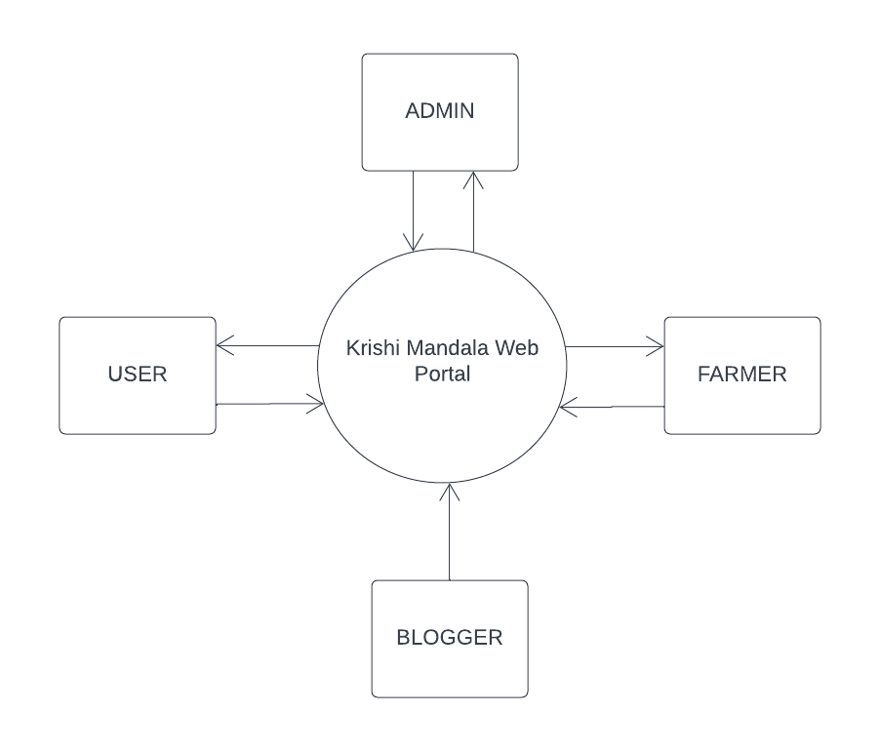

**1-level DFD**

In 1-level DFD, a context diagram is decomposed into multiple bubbles/processes. In this level, we highlight the main objectives of the system and breakdown the high-level process of 0-level DFD into subprocesses.

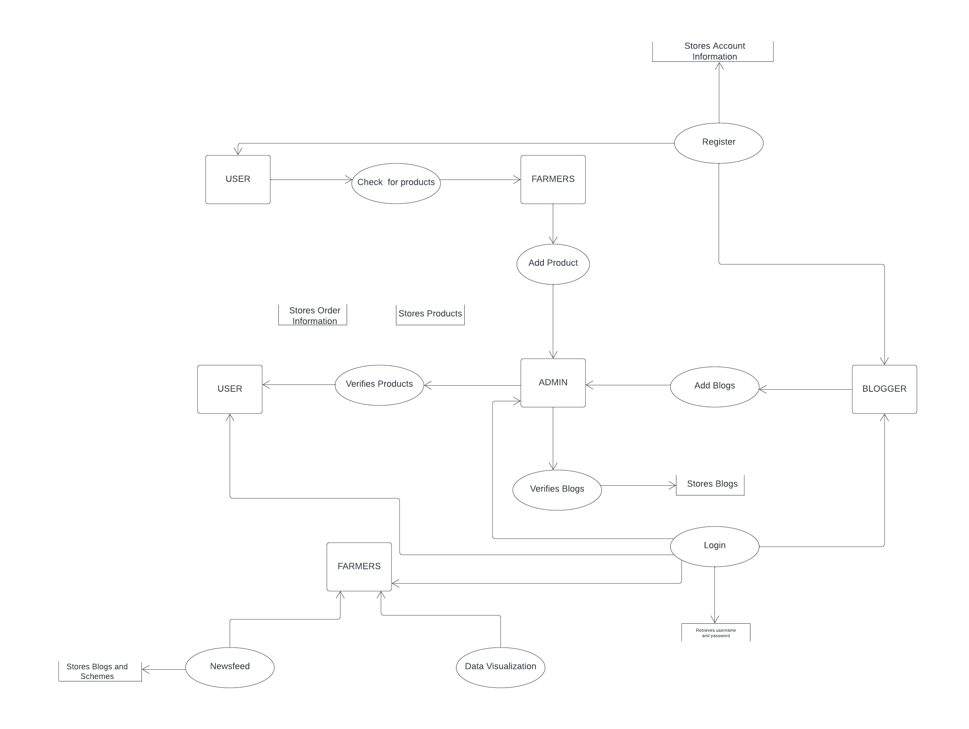

ENTITY RELATIONSHIP DIAGRAM

An Entity Relationship (ER) Diagram is a type of flowchart that illustrates how “entities” such as people, objects or concepts relate to each other within a system. ER Diagrams are most often used to design or debug relational databases in the fields of software engineering, business information systems, education and research.

Uses of entity relationship diagrams

Database design

Database troubleshooting

Business information systems

Education

Research

**->Entity**

A definable thing—such as a person, object, concept or event—that can have data stored about it. Think of entities as nouns

**->Relationship**

How entities act upon each other or are associated with each other. Think of relationships as verbs. For example, the named student might register for a course.

**SYSTEM IMPLEMENTATION**

Implementation is a process of ensuring that the information system is operational. It involves −

* Constructing a new system from scratch
* Constructing a new system from the existing one.

Implementation allows the users to take over its operation for use and evaluation.

Implementation includes **user notification, user training, installation of hardware, installation of software onto production computers, and integration of the system into daily work processes**. This phase continues until the system is operating in production in accordance with the defined user requirements.

This is the process in which the developed system is handed over to the client. The old system is dispensed, new system is put into operation for use and all the end users are trained to manage and maintain the new system.

from datetime import datetime

from turtle import title

from unicodedata import category

from urllib import request

from fastapi import FastAPI, Request, Cookie

from fastapi.params import Form

from fastapi.responses import HTMLResponse

from fastapi.staticfiles import StaticFiles

from fastapi.templating import Jinja2Templates

import sqlite3

from starlette.middleware.sessions import SessionMiddleware

from starlette.datastructures import URL, URLPath

import starlette.status as status

from starlette.responses import RedirectResponse,Response

from fastapi.security import HTTPBasic, HTTPBasicCredentials

from Telegram import Telegram

app = FastAPI()

security = HTTPBasic()

telegram = Telegram("5235854735:AAFPlFyow2J-nL1n03-EeY-mQYer56cQ10A","krishi_mandala")

app.mount("/static", StaticFiles(directory="static"), name="static")

app.add_middleware(SessionMiddleware, secret_key='MyApp')

templates = Jinja2Templates(directory="templates")

@app.get("/", response_class=HTMLResponse)

def index(request : Request):

return templates.TemplateResponse("index.html",{"request" : request})

@app.get("/Products", response_class=HTMLResponse)

def Products(request : Request):

return templates.TemplateResponse("Products.html",{"request" : request})

@app.get("/aboutus", response_class=HTMLResponse)

def Products(request : Request):

return templates.TemplateResponse("aboutus.html",{"request" : request})

@app.get("/logout/aboutus", response_class=HTMLResponse)

def logout(request: Request):

request.session.clear()

return RedirectResponse("/aboutus", status_code=status.HTTP_302_FOUND)

@app.get("/admin/sendmessage", response_class=HTMLResponse)

def Products(request : Request):

return templates.TemplateResponse("/admin/send.html",{"request" : request})

@app.post("/admin/sendmessage",response_class=HTMLResponse)

def addblog(request : Request, message : str = Form(...)):

telegram.sendmessage(message)

return RedirectResponse("/admin/dashboard",status_code=status.HTTP_302_FOUND)

@app.get("/newsfeed", response_class=HTMLResponse)

def newsfeed(request : Request):

con = sqlite3.connect("Myapp.db")

con.row_factory = sqlite3.Row

cur = con.cursor()

cur.execute("select * from blog")

blogs = cur.fetchall()

con.close

return templates.TemplateResponse("newsfeed.html",{"request" : request,"blogs" : blogs })

@app.get("/chart", response_class=HTMLResponse)

def chart(request : Request):

return templates.TemplateResponse("chart.html",{"request" : request})

@app.get("/upload", response_class=HTMLResponse)

def upload(request : Request):

return templates.TemplateResponse("upload.html",{"request" : request})

@app.get("/upload_home", response_class=HTMLResponse)

def upload_home(request : Request):

con = sqlite3.connect("Myapp.db")

con.row_factory = sqlite3.Row

cur = con.cursor()

cur.execute("select * from blog")

blogs = cur.fetchall()

con.close

return templates.TemplateResponse("upload_home.html",{"request" : request,"blogs" : blogs })

@app.post("/upload",response_class=HTMLResponse)

def addblog(request : Request, name : str = Form(...), title : str = Form(...), content : str = Form(...), image :str =Form(...)):

with sqlite3.connect("Myapp.db") as con:

cur = con.cursor()

cur.execute("INSERT into verify_blog(name,title,content,image) values(?,?,?,?)",(name,title,content,image))

con.commit()

return RedirectResponse("/upload_home",status_code=status.HTTP_302_FOUND)

@app.post("/admin/upload",response_class=HTMLResponse)

def addblog(request : Request, name : str = Form(...), title : str = Form(...), content : str = Form(...), image :str =Form(...)):

with sqlite3.connect("Myapp.db") as con:

cur = con.cursor()

cur.execute("INSERT into blog(name,title,content,image) values(?,?,?,?)",(name,title,content,image))

con.commit()

telegram.sendmessage(content)

return RedirectResponse("/admin/dashboard",status_code=status.HTTP_302_FOUND)

@app.get("/login", response_class=HTMLResponse)

def login(request : Request):

return templates.TemplateResponse("login.html",{"request" : request})

URLPath(path="/login")

@app.post("/login", response_class=HTMLResponse)

def do_login(request: Request, response: Response, username: str = Form(...), password: str = Form(...)):

con = sqlite3.connect("Myapp.db")

con.row_factory = sqlite3.Row

cur = con.cursor()

cur.execute("select * from farmer where username =? and password=?", [username, password])

farmer = cur.fetchone()

if not farmer:

return templates.TemplateResponse("login.html", {"request": request, "msg": "Invalid Username or Password"})

elif farmer['role'] == '1':

request.session.setdefault("isLogin", True)

request.session.setdefault('username', farmer['username'])

request.session.setdefault('role',farmer['role'])

return RedirectResponse("/", status_code=status.HTTP_302_FOUND)

elif farmer['role'] == '2':

request.session.setdefault("isLogin", True)

request.session.setdefault('uid', farmer['id'])

request.session.setdefault('username', farmer['username'])

request.session.setdefault('role',farmer['role'])

return RedirectResponse("/", status_code=status.HTTP_302_FOUND)

else:

request.session.setdefault("isLogin", True)

request.session.setdefault('username', farmer['username'])

request.session.setdefault('role',farmer['role'])

return RedirectResponse("/upload_home", status_code=status.HTTP_302_FOUND)

@app.get("/register", response_class=HTMLResponse)

def register(request : Request):

return templates.TemplateResponse("register.html",{"request" : request})

@app.get("/crops", response_class=HTMLResponse)

def crops(request : Request):

con = sqlite3.connect("Myapp.db")

con.row_factory = sqlite3.Row

cur = con.cursor()

cur.execute("select * from products where category = 'crops'")

crops = cur.fetchall()

con.close

return templates.TemplateResponse("crops.html",{"request" : request,"crops" : crops })

@app.get("/fruits", response_class=HTMLResponse)

def fruits(request : Request):

con = sqlite3.connect("Myapp.db")

con.row_factory = sqlite3.Row

cur = con.cursor()

cur.execute("select * from products where category = 'Fruits'")

fruits = cur.fetchall()

con.close

return templates.TemplateResponse("fruits.html",{"request" : request,"fruits" : fruits })

@app.get("/vegetables", response_class=HTMLResponse)

def vegetables(request : Request):

con = sqlite3.connect("Myapp.db")

con.row_factory = sqlite3.Row

cur = con.cursor()

cur.execute("select * from products where category = 'Vegetables' ")

vegetables = cur.fetchall()

con.close

return templates.TemplateResponse("vegetables.html",{"request" : request , "vegetables" : vegetables})

@app.get("/admin/orders", response_class=HTMLResponse)

def admin_orders(request: Request):

con = sqlite3.connect("Myapp.db")

con.row_factory = sqlite3.Row

cur = con.cursor()

cur.execute("SELECT *, o.id as oid from farmer u, products p, orders o where o.uid = u.id and o.pid = p.id")

orders = cur.fetchall()

con.close

return templates.TemplateResponse("/admin/orders.html", {"request": request, "orders": orders})

@app.get("/admin/orders", response_class=HTMLResponse)

def admin_orders(request: Request):

return templates.TemplateResponse("/admin/orders.html", {"request": request})

@app.get("/admin/orders_view/{oid}", response_class=HTMLResponse)

def admin_order_view(request: Request, oid: int = 0):

return templates.TemplateResponse("/admin/orders_view.html", {"request": request})

@app.get("/seeds", response_class=HTMLResponse)

def seeds(request : Request):

con = sqlite3.connect("Myapp.db")

con.row_factory = sqlite3.Row

cur = con.cursor()

cur.execute("select * from products where category = 'Seeds' ")

seeds = cur.fetchall()

con.close

return templates.TemplateResponse("seeds.html",{"request" : request, "seeds" : seeds})

@app.get("/fertilizer", response_class=HTMLResponse)

def seeds(request : Request):

con = sqlite3.connect("Myapp.db")

con.row_factory = sqlite3.Row

cur = con.cursor()

cur.execute("select * from products where category = 'Fertilizers' ")

fertilzer = cur.fetchall()

con.close

return templates.TemplateResponse("fertilizer.html",{"request" : request, "fertilizer" : fertilzer})

@app.get("/logout", response_class=HTMLResponse)

def logout(request: Request):

request.session.clear()

return RedirectResponse("/login", status_code=status.HTTP_302_FOUND)

@app.get("/contactus", response_class=HTMLResponse)

def contactus(request : Request):

con = sqlite3.connect("Myapp.db")

con.row_factory = sqlite3.Row

cur = con.cursor()

cur.execute("select * from contact")

items = cur.fetchall()

con.close

return templates.TemplateResponse("contactus.html",{"request" : request, "items" : items})

@app.post("/contactus",response_class=HTMLResponse)

def addcontact(request : Request, name : str = Form(...), type : str = Form(...), report : str = Form(...) ):

with sqlite3.connect("Myapp.db") as con:

cur = con.cursor()

cur.execute("INSERT into contact(name,type,report) values(?,?,?)",(name,type,report))

con.commit()

return RedirectResponse("/contactus",status_code=status.HTTP_302_FOUND)

@app.get("/admin/index", response_class=HTMLResponse)

def admin_index(request: Request):

request.session.clear()

return templates.TemplateResponse("/admin/index.html", {"request" : request})

@app.post("/admin/", response_class=HTMLResponse)

def admin_index(request: Request, username: str = Form(...), password: str = Form(...)):

con = sqlite3.connect("Myapp.db")

con.row_factory = sqlite3.Row

cur = con.cursor()

cur.execute("select * from admin where username =? and password=?", [username, password])

admin = cur.fetchone()

if not admin:

return templates.TemplateResponse("/admin/index.html", {"request": request, "msg": "Invalid Username or Password"})

else:

request.session.setdefault("isLogin", True)

request.session.setdefault('username', admin['username'])

request.session.setdefault('uid', admin['id'])

request.session.setdefault('role', admin['role'])

return RedirectResponse("/admin/dashboard", status_code=status.HTTP_302_FOUND)

@app.get("/admin/dashboard", response_class=HTMLResponse)

def dashboard(request: Request):

return templates.TemplateResponse("/admin/dashboard.html", {"request": request })

@app.get("/admin/products", response_class=HTMLResponse)

def admin_products(request: Request):

con = sqlite3.connect("Myapp.db")

con.row_factory = sqlite3.Row

cur = con.cursor()

cur.execute("select * from products")

products = cur.fetchall()

con.close

return templates.TemplateResponse("/admin/products.html", {"request": request, "products": products})

@app.get("/admin/products_create", response_class=HTMLResponse)

def products_create(request: Request):

con = sqlite3.connect("Myapp.db")

con.row_factory = sqlite3.Row

cur = con.cursor()

cur.execute("select * from verify")

products = cur.fetchall()

con.close

return templates.TemplateResponse("/admin/products_create.html", {"request": request, "products": products})

@app.post("/admin/products_create", response_class=HTMLResponse)

def admin_products_create(request: Request, pname:str = Form(...), price: str = Form(...), image: str = Form(...), details: str = Form(...), category:str = Form(...)):

with sqlite3.connect("Myapp.db") as con:

cur = con.cursor()

cur.execute("INSERT into products(pname, price, image, details, category) values(?, ?, ?, ?, ?)",(pname, price, image, details, category))

con.commit()

return RedirectResponse("/admin/products",status_code=status.HTTP_302_FOUND)

@app.get("/products_create", response_class=HTMLResponse)

def products_create(request: Request):

return templates.TemplateResponse("products_create.html", {"request": request })

@app.post("/products_create", response_class=HTMLResponse)

def products_create(request: Request, pname:str = Form(...), price: str = Form(...), category:str = Form(...)):

with sqlite3.connect("Myapp.db") as con:

cur = con.cursor()

cur.execute("INSERT into verify(pname, price, category) values(?, ?, ?)",(pname, price,category))

con.commit()

return RedirectResponse("/Products", status_code=status.HTTP_302_FOUND )

@app.get("/addtocart", response_class=HTMLResponse)

async def addtocart(request: Request, pid:int = 1, qty:int = 1):

uid = request.session.get('uid')

with sqlite3.connect("Myapp.db", check_same_thread=False) as con:

cur = con.cursor()

cur.execute("INSERT into carts(pid, qty, uid) values(?,?,?)",(pid, qty, uid))

con.commit()

return RedirectResponse("/cart", status_code=status.HTTP_302_FOUND)

@app.get("/cart", response_class=HTMLResponse)

def cart(request: Request):

if not request.session.get('isLogin'):

return RedirectResponse('/login', status_code=status.HTTP_302_FOUND)

uid = request.session.get('uid')

con = sqlite3.connect("Myapp.db")

con.row_factory = sqlite3.Row

cur = con.cursor()

cur.execute("SELECT *,c.id as cid from farmer u,carts c, products p where u.id=c.uid and c.pid=p.id and c.uid =? ", [uid])

items = cur.fetchall()

con.close

return templates.TemplateResponse("/cart.html", {"request": request, "items": items})

@app.get("/admin/products_edit/{pid}", response_class=HTMLResponse)

def admin_product_edit(request: Request,pid: int = 0):

con = sqlite3.connect("Myapp.db")

con.row_factory = sqlite3.Row

cur = con.cursor()

cur.execute("select * from products where id=?" , [pid])

products = cur.fetchall()

con.close

return templates.TemplateResponse("/admin/products_edit.html", {"request": request , "products":products , "pid" : pid} )

@app.get("/admin/verify_edit/{pid}", response_class=HTMLResponse)

def admin_product_edit(request: Request, pid: int = 0):

con = sqlite3.connect("Myapp.db")

con.row_factory = sqlite3.Row

cur = con.cursor()

cur.execute("select * from verify where id=?" , [pid])

products = cur.fetchall()

con.close

return templates.TemplateResponse("/admin/verify_edit.html", {"request": request , "products":products , "pid" : pid} )

@app.get("/admin/blog_edit/{bid}", response_class=HTMLResponse)

def admin_blog_edit(request: Request, bid: int = 0):

con = sqlite3.connect("Myapp.db")

con.row_factory = sqlite3.Row

cur = con.cursor()

cur.execute("select * from verify_blog where id=?" , [bid])

bloggs = cur.fetchall()

con.close

return templates.TemplateResponse("/admin/blog_edit.html", {"request": request , "bloggs":bloggs , "bid" : bid} )

@app.get("/blog_edit/{bid}", response_class=HTMLResponse)

def admin_blog_edit(request: Request, bid: int = 0):

con = sqlite3.connect("Myapp.db")

con.row_factory = sqlite3.Row

cur = con.cursor()

cur.execute("select * from blog where id=?" , [bid])

blogs = cur.fetchall()

con.close

return templates.TemplateResponse("blog_edit.html", {"request": request , "blogs": blogs , "bid" : bid} )

@app.get("/delete/{bid}", response_class=HTMLResponse)

def blog_edit(request: Request, bid: int = 0):

con = sqlite3.connect("Myapp.db")

con.row_factory = sqlite3.Row

cur = con.cursor()

cur.execute("delete from blog where id=?" , [bid])

con.commit()

con.close

return RedirectResponse("/upload_home", status_code=status.HTTP_302_FOUND )

@app.get("/buynow/{pid}", response_class=HTMLResponse)

def buynow(request: Request, pid: int):

if not request.session.get('isLogin'):

return RedirectResponse('/login', status_code=status.HTTP_302_FOUND)

con = sqlite3.connect("Myapp.db")

con.row_factory = sqlite3.Row

cur = con.cursor()

cur.execute("select * from products where id =?", [pid])

description = cur.fetchall()

con.close

return templates.TemplateResponse("buynow.html", {"request": request, "pid": pid, "description": description[0]})

@app.get("/admin/products_delete/{pid}", response_class=HTMLResponse)

def admin_product_delete(request: Request, pid: int = 0):

con = sqlite3.connect("Myapp.db")

con.row_factory = sqlite3.Row

cur = con.cursor()

cur.execute("delete from products where id=?" , [pid])

con.commit()

con.close

return RedirectResponse("/admin/products", status_code=status.HTTP_302_FOUND )

@app.get("/deletecart/{cid}", response_class=HTMLResponse)

def delete_cart_item(request: Request, cid: int):

con = sqlite3.connect("Myapp.db")

con.row_factory = sqlite3.Row

cur = con.cursor()

cur.execute("Delete from carts where id =?", [cid])

con.commit()

con.close

return RedirectResponse("/cart", status_code=status.HTTP_302_FOUND)

@app.get("/admin/verify", response_class=HTMLResponse)

def admin_products(request: Request):

con = sqlite3.connect("Myapp.db")

con.row_factory = sqlite3.Row

cur = con.cursor()

cur.execute("select * from verify")

products = cur.fetchall()

con.close

return templates.TemplateResponse("/admin/verify.html", {"request": request, "products": products})

@app.get("/admin/verify_blog", response_class=HTMLResponse)

def admin_products(request: Request):

con = sqlite3.connect("Myapp.db")

con.row_factory = sqlite3.Row

cur = con.cursor()

cur.execute("select * from verify_blog")

bloggs = cur.fetchall()

con.close

return templates.TemplateResponse("/admin/verify_blog.html", {"request": request, "bloggs": bloggs})

@app.get("/logout", response_class=HTMLResponse)

def logout(request: Request):

request.session.clear()

return RedirectResponse("/login", status_code=status.HTTP_302_FOUND)

@app.get("/admin/logout", response_class=HTMLResponse)

def logout(request: Request):

request.session.clear()

return RedirectResponse("/admin/index", status_code=status.HTTP_302_FOUND)

@app.get("/confrim", response_class=HTMLResponse)

def confrim(request: Request):

uid = request.session.get('uid')

with sqlite3.connect("Myapp.db", check_same_thread=False) as con:

cur = con.cursor()

cur.execute("SELECT * from carts where uid = ? ",[uid])

carts = cur.fetchall()

for cart in carts:

print(cart)

now = datetime.now()

order_time = now.strftime("%d/%m/%Y %H:%M:%S")

cur.execute("INSERT into orders(pid, qty, uid,status,date) values(?,?,?,?,?)",

[cart[1], cart[2], cart[3], "ORDERED", order_time])

cur.execute("Delete from carts where uid = ? ", [uid])

con.commit()

return RedirectResponse("/orders", status_code=status.HTTP_302_FOUND)

@app.get("/orders",response_class=HTMLResponse)

def orders(request : Request):

if not request.session.get('isLogin'):

return RedirectResponse('/login', status_code=status.HTTP_302_FOUND)

uid = request.session.get('uid')

con = sqlite3.connect("Myapp.db")

con.row_factory = sqlite3.Row

cur = con.cursor()

cur.execute("SELECT *,o.id as oid from farmer u,orders o, products p where u.id=o.uid and o.pid=p.id and o.uid =?",[uid])

orders = cur.fetchall()

con.close

return templates.TemplateResponse("/orders.html", {"request": request, "orders": orders})

@app.get("/admin/products_delete/{pid}", response_class=HTMLResponse)

def admin_product_delete(request: Request, pid: int = 0):

return RedirectResponse("/admin/products", status_code=status.HTTP_302_FOUND)

@app.get("/farmerregister", response_class=HTMLResponse)

def farmerregister(request : Request):

con = sqlite3.connect("Myapp.db")

con.row_factory = sqlite3.Row

cur = con.cursor()

cur.execute("select * from farmer")

items = cur.fetchall()

con.close

return templates.TemplateResponse("farmerregister.html",{"request" : request, "items" : items})

@app.post("/farmerregister",response_class=HTMLResponse)

def addfarmer(request : Request, Name : str = Form(...), Age : int = Form(...), Gender : str = Form(...), PhoneNumber : str = Form(...), AadharNumber:str =Form(...), Address : str = Form(...), District:str = Form(...),State : str = Form(...),FarmCategory : str = Form(...),nameb : str = Form(...), accno : int = Form(...), bankName : str = Form(...),ifsccode : str = Form(...) ,username : str = Form(...), password : str = Form(...) ):

with sqlite3.connect("Myapp.db") as con:

cur = con.cursor()

cur.execute("INSERT into farmer(Name,Age,Gender,PhoneNumber,AadharNumber,Address,District,State,FarmCategory,nameb,accno,bankName,ifsccode,username,password,role,type) values(?,?,?,?,?,?,?,?,?,?,?,?,?,?,?,?,?)",(Name,Age,Gender,PhoneNumber,AadharNumber,Address,District,State,FarmCategory,nameb,accno,bankName,ifsccode,username,password,"1",'Farmer'))

con.commit()

return RedirectResponse("/login",status_code=status.HTTP_302_FOUND)

@app.get("/userregister", response_class=HTMLResponse)

def userregister(request : Request):

con = sqlite3.connect("Myapp.db")

con.row_factory = sqlite3.Row

cur = con.cursor()

cur.execute("select * from farmer")

items = cur.fetchall()

con.close

return templates.TemplateResponse("userregister.html",{"request" : request, "items" : items})

@app.post("/userregister",response_class=HTMLResponse)

def addfarmer(request : Request, Name : str = Form(...), PhoneNumber : str = Form(...), Address : str = Form(...), District:str = Form(...),State : str = Form(...),Pincode : str = Form(...),username : str = Form(...), password : str = Form(...) ):

with sqlite3.connect("Myapp.db") as con:

cur = con.cursor()

cur.execute("INSERT into farmer(Name,PhoneNumber,Address,District,State,Pincode,username,password,role,type) values(?,?,?,?,?,?,?,?,?,?)",(Name,PhoneNumber,Address,District,State,Pincode,username,password,"2",'User'))

con.commit()

return RedirectResponse("/login",status_code=status.HTTP_302_FOUND)

@app.get("/authorregister", response_class=HTMLResponse)

def authorregister(request : Request):

con = sqlite3.connect("Myapp.db")

con.row_factory = sqlite3.Row

cur = con.cursor()

cur.execute("select * from farmer")

items = cur.fetchall()

con.close

return templates.TemplateResponse("authorregister.html",{"request" : request, "items" : items})

@app.post("/authorregister",response_class=HTMLResponse)

def addfarmer(request : Request, Name : str = Form(...), Gender : str = Form(...), PhoneNumber: str = Form(...),Address : str = Form(...),District : str = Form(...),State : str = Form(...), username : str = Form(...), password : str = Form(...)):

with sqlite3.connect("Myapp.db") as con:

cur = con.cursor()

cur.execute("INSERT into farmer(Name,Gender,PhoneNumber,Address,District,State,username,password,role,type) values(?,?,?,?,?,?,?,?,?,?)",(Name,Gender,PhoneNumber,Address,District,State,username,password,"3",'Blogger'))

con.commit()

return RedirectResponse("/login",status_code=status.HTTP_302_FOUND)

**############# GRAPH IMPLEMENTATION###############**

@app.get("/products_data")

def products_data(request: Request):

con = sqlite3.connect("Myapp.db")

con.row_factory = sqlite3.Row

cur = con.cursor()

cur.execute("select * from products")

items = cur.fetchall()

con.close

return items

@app.get("/products_types")

def products_data(request: Request):

con = sqlite3.connect("Myapp.db")

con.row_factory = sqlite3.Row

cur = con.cursor()

cur.execute("select category,count(*) as count from products GROUP by category")

items = cur.fetchall()

con.close

return items

@app.get("/farmer_types")

def farmer_data(request: Request):

con = sqlite3.connect("Myapp.db")

con.row_factory = sqlite3.Row

cur = con.cursor()

cur.execute("select type,count(*) as count from farmer GROUP by type")

items = cur.fetchall()

con.close

return items

@app.get("/ragi_chart")

def products_chart(request: Request):

con = sqlite3.connect("Myapp.db")

con.row_factory = sqlite3.Row

cur = con.cursor()

cur.execute("select * from chart where pname= 'Ragi'")

items = cur.fetchall()

con.close

return items

@app.get("/rice_chart")

def products_chart(request: Request):

con = sqlite3.connect("Myapp.db")

con.row_factory = sqlite3.Row

cur = con.cursor()

cur.execute("select * from chart where pname= 'Rice'")

items = cur.fetchall()

con.close

return items

@app.get("/banana_chart")

def products_chart(request: Request):

con = sqlite3.connect("Myapp.db")

con.row_factory = sqlite3.Row

cur = con.cursor()

cur.execute("select * from chart where pname= 'Banana'")

items = cur.fetchall()

con.close

return items

@app.get("/Guava_chart")

def products_chart(request: Request):

con = sqlite3.connect("Myapp.db")

con.row_factory = sqlite3.Row

cur = con.cursor()

cur.execute("select * from chart where pname= 'Guava'")

items = cur.fetchall()

con.close

return items

@app.get("/tomato_chart")

def products_chart(request: Request):

con = sqlite3.connect("Myapp.db")

con.row_factory = sqlite3.Row

cur = con.cursor()

cur.execute("select * from chart where pname= 'Tomato'")

items = cur.fetchall()

con.close

return items

@app.get("/onion_chart")

def products_chart(request: Request):

con = sqlite3.connect("Myapp.db")

con.row_factory = sqlite3.Row

cur = con.cursor()

cur.execute("select * from chart where pname= 'Onion'")

items = cur.fetchall()

con.close

return items

@app.get("/admin/verify_edit/{pid}", response_class=HTMLResponse)

def admin_product_edit(request: Request, pid: int = 0):

con = sqlite3.connect("Myapp.db")

con.row_factory = sqlite3.Row

cur = con.cursor()

cur.execute("select * from verify where id=?" , [pid])

products = cur.fetchall()

con.close

return templates.TemplateResponse("/admin/verify_edit.html", {"request": request , "products":products , "pid" : pid} )

**TESTING**

Testing is the process of analyzing a software item to detect the differences between existing and required conditions and to evaluate the features of the software item.

System Testing is carried out on the whole system in the context of either system requirement specifications or functional requirement specifications or in the context of both. System testing tests the design and behavior of the system and also the expectations of the customer. It is performed to test the system beyond the bounds mentioned in the software requirements specification (SRS).

**Purpose of Testing:**

* Testing is a process of executing a program with the intent of finding an error.
* To check whether the system is working as required or not.
* Testing is to cause failures in order to make faults visible, so that faults can be fixed and not be delivered in the code that goes to customer.
* To prove that the software system is free of any errors.
* Testing is used to establish the presence of defects and to show fitness for purpose.

**Testing Principles:**

* All tests should be traceable to customer requirement.
* Testing should be planned long before testing begins.
* Exhaustive testing is not impossible.
* Testing by third party will be very effective.

**Test Process:**

1.Unit Testing

2.Module Testing

3.Integration Testing

4.System Testing

5.Acceptance Testing

**1.Unit Testing:**

Individual components are tested to ensure that they operate correctly. Each component is tested independently, without other system components.

**2. Module Testing:**

A module is a collection of dependent components such as an object class, an abstract data type or some collection of procedures and functions. A module encapsulates related components so that it can be tested without referring other system modules.

**3. Integration Testing:**

This phase involves testing collection of modules which have been integrated into sub-systems. Sub-systems may be independently designed and implemented. The most common problems which arise in large software system are subsystem interface mismatches. The subsystem test process should therefore concentrate on the detection of interface errors by rigorously exercising these interfaces.

**4. System Testing:**

The subsystems are integrated to make-up the entire system. The testing process is concerned with finding errors that result from unanticipated interactions between sub-systems and system components. It is also concerned with validating that the system meets its functional and non-functional requirements.

**5. Acceptance Testing:**

This is the final stage in the testing process before the system is accepted for operational use. The system is tested with data supplied by the client rather than simulated test data.

**TEST CASE**

|  |  |  |  |
| --- | --- | --- | --- |
| Project Name | Krishi Mandala |  |  |
| Module Name | Login |  |  |
| Checked by | Shreyas G Bharadwaj |  |  |
| Created date | 31-Jan-2022 |  |  |
| Reviewed by | Sangeetha S |  |  |
| Reviewed date | 02-Feb-2022 |  |  |

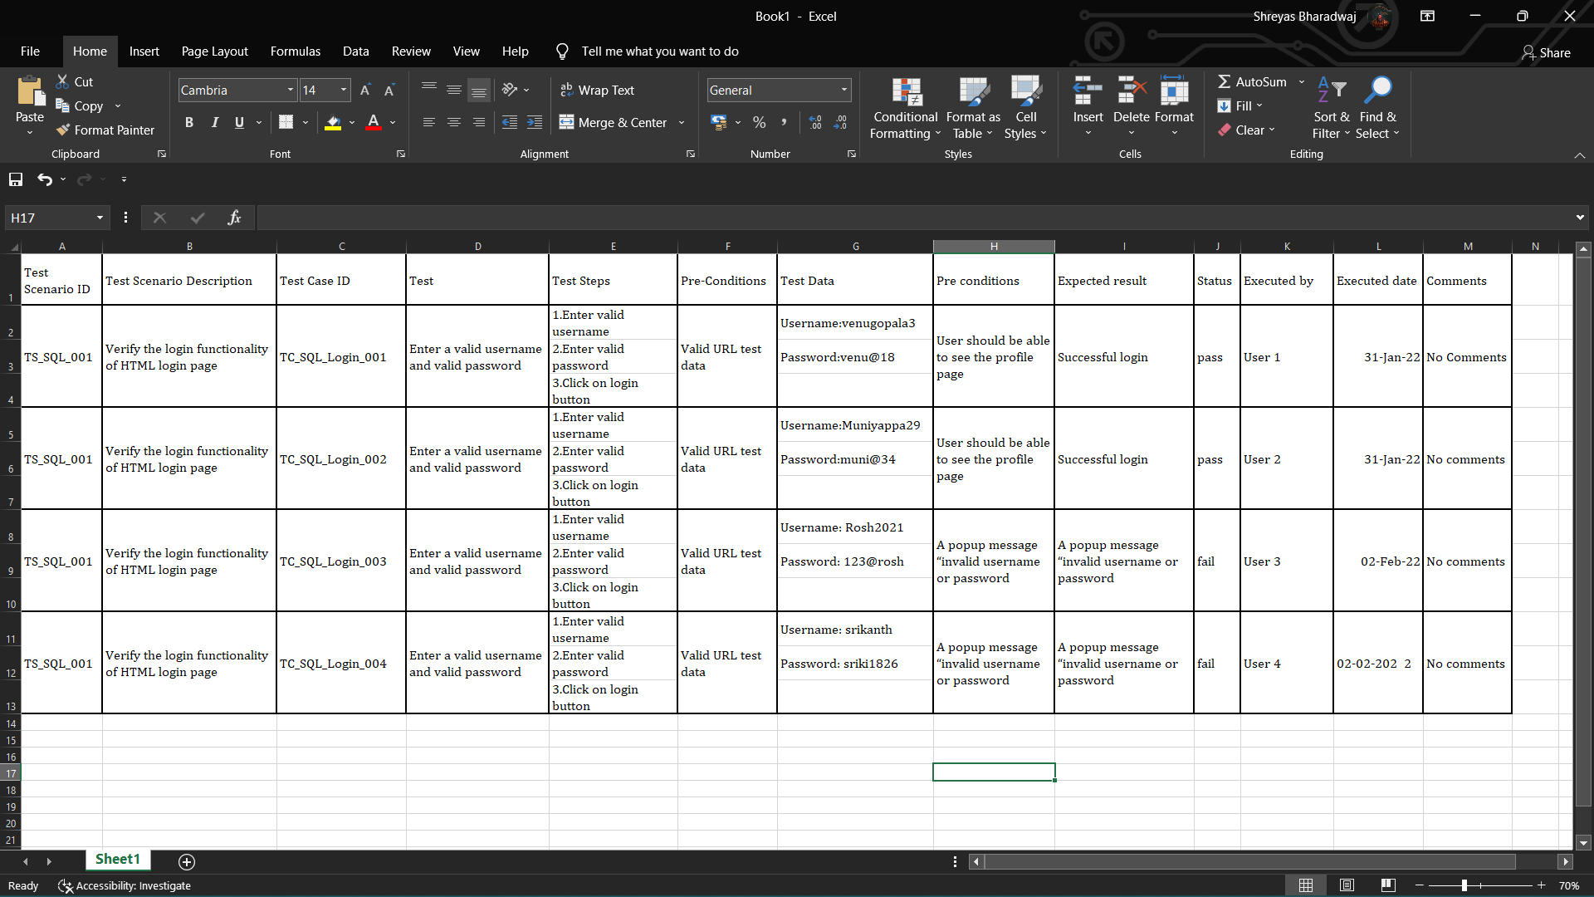

**SAMPLE OUT**

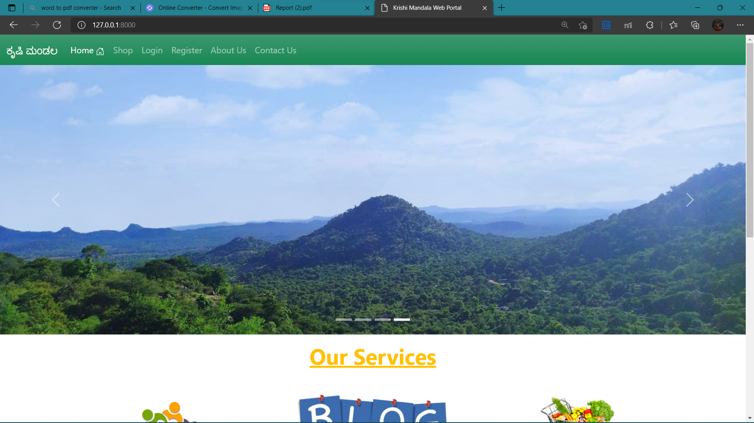

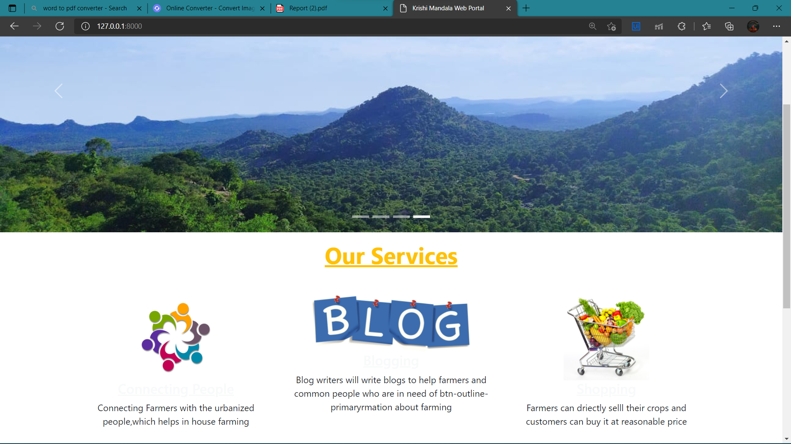

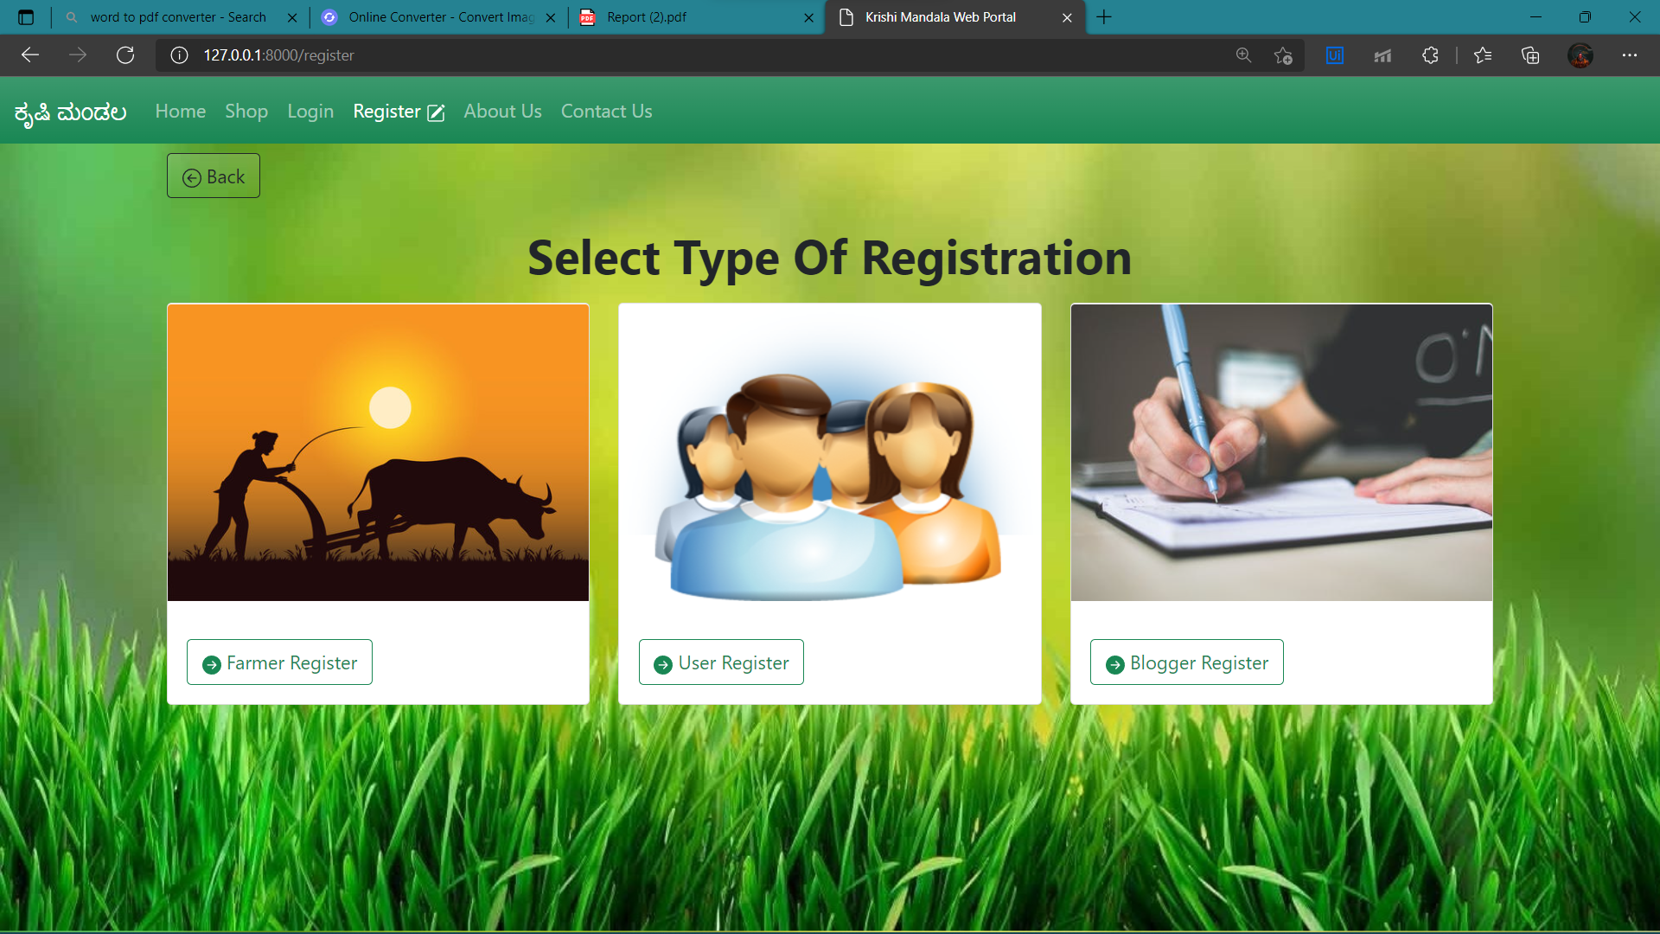

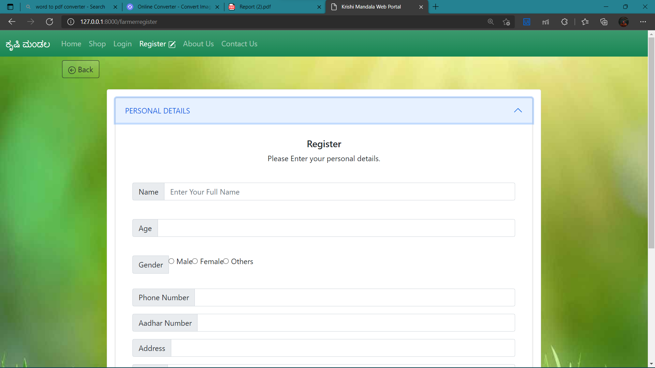

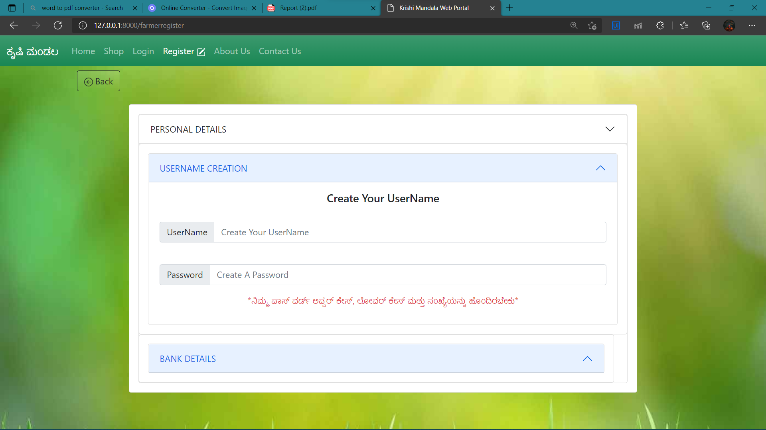

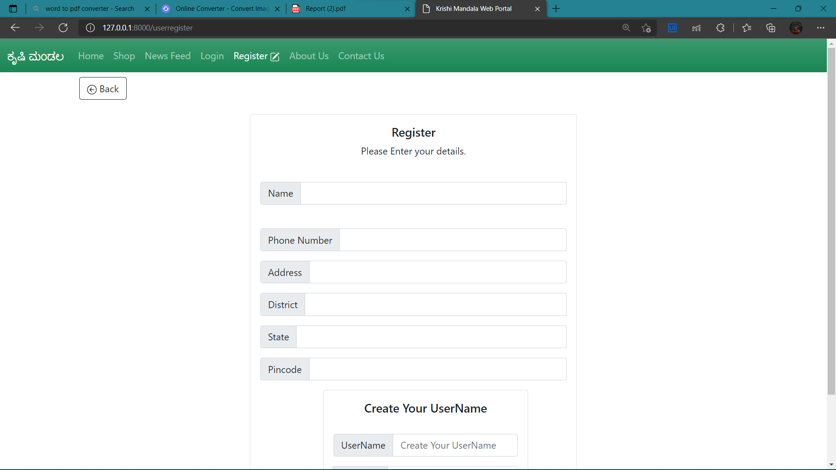

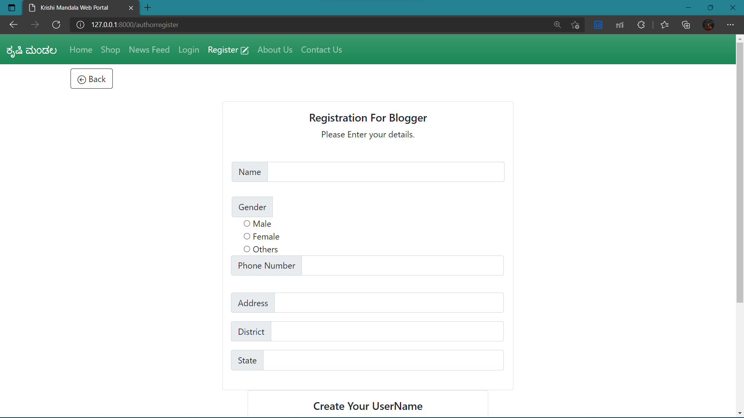

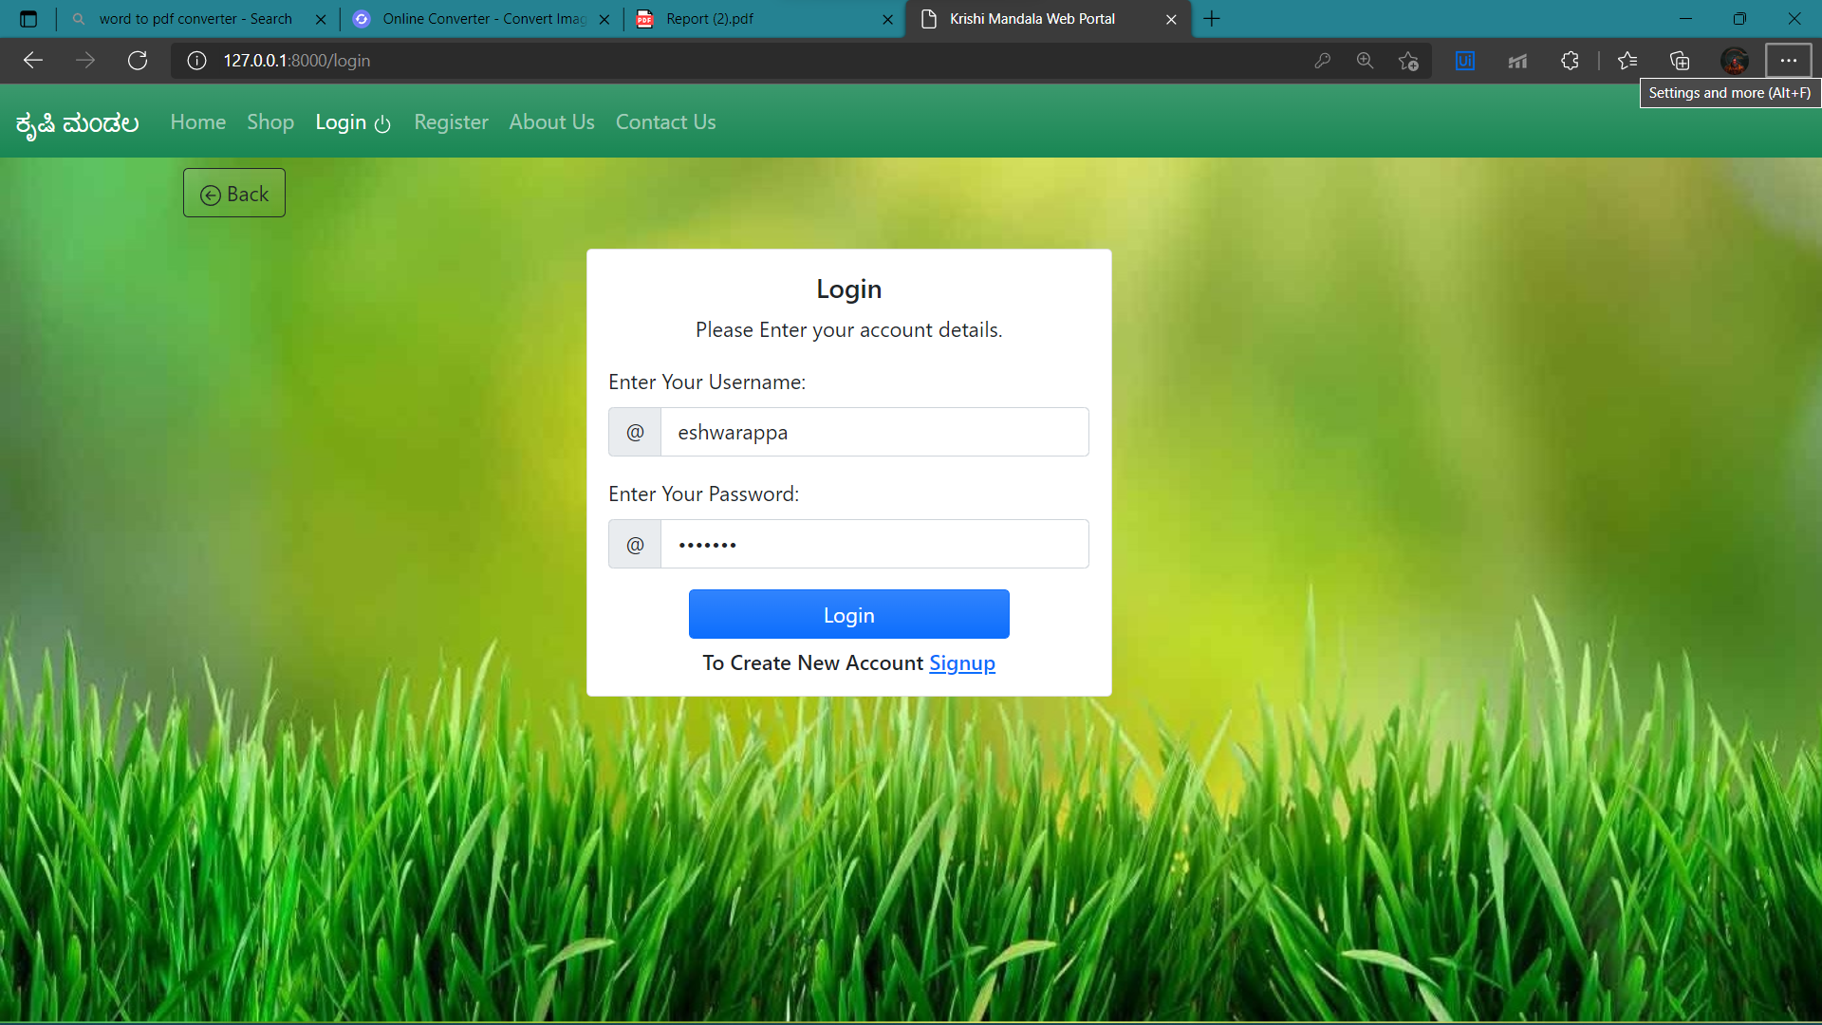

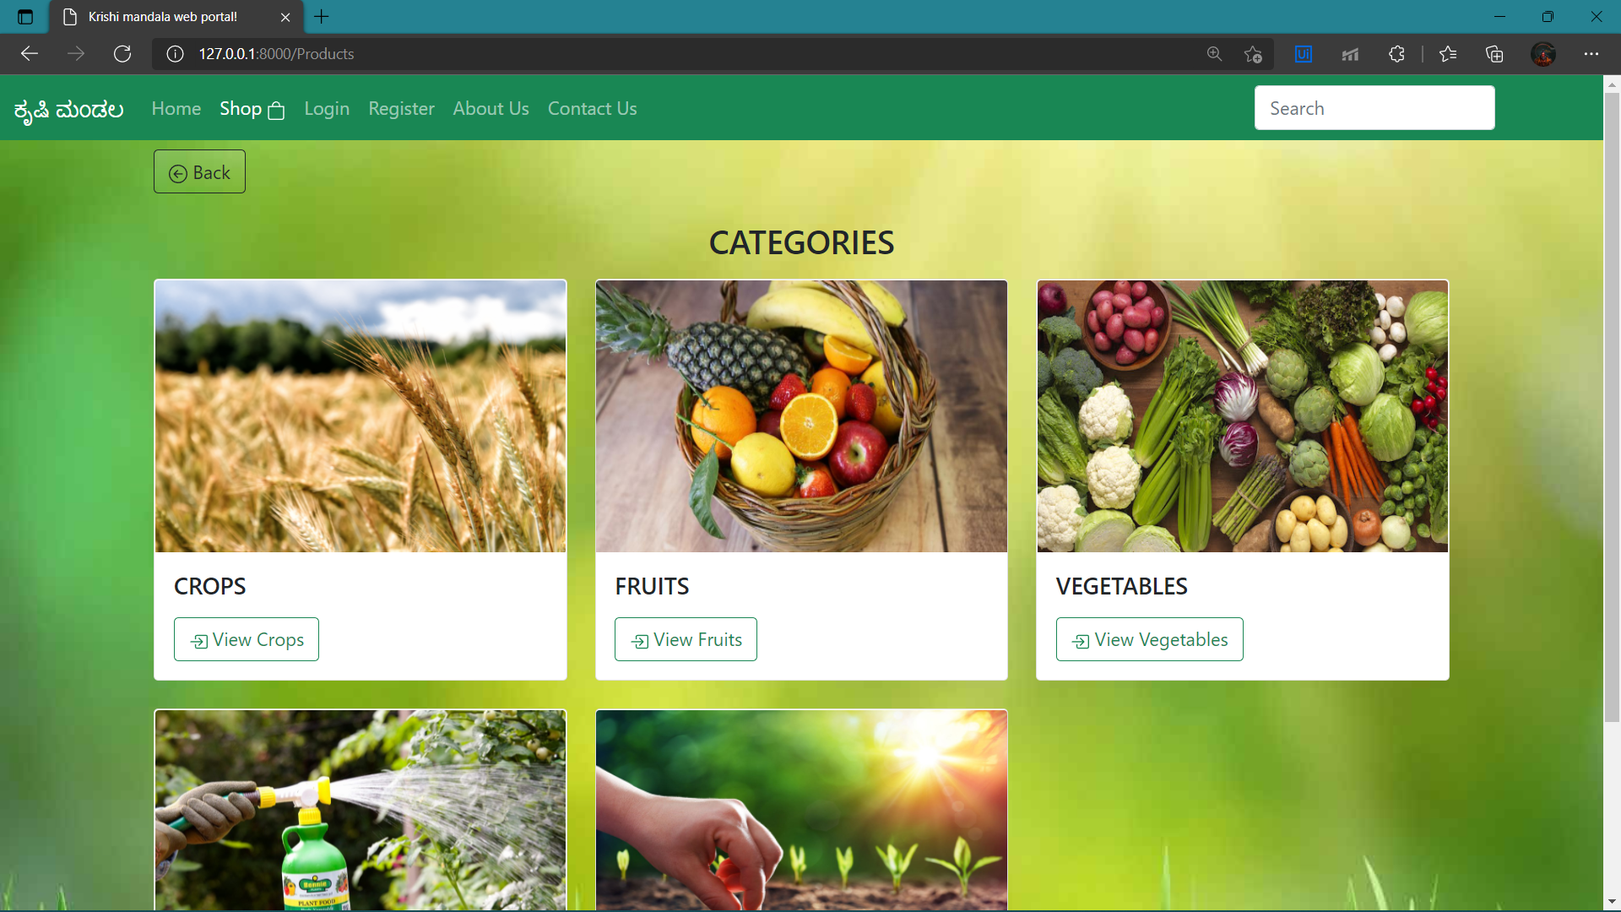

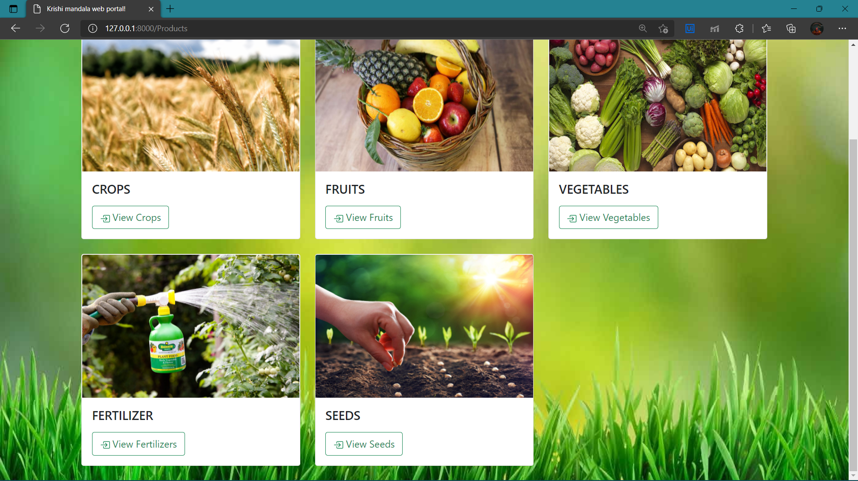

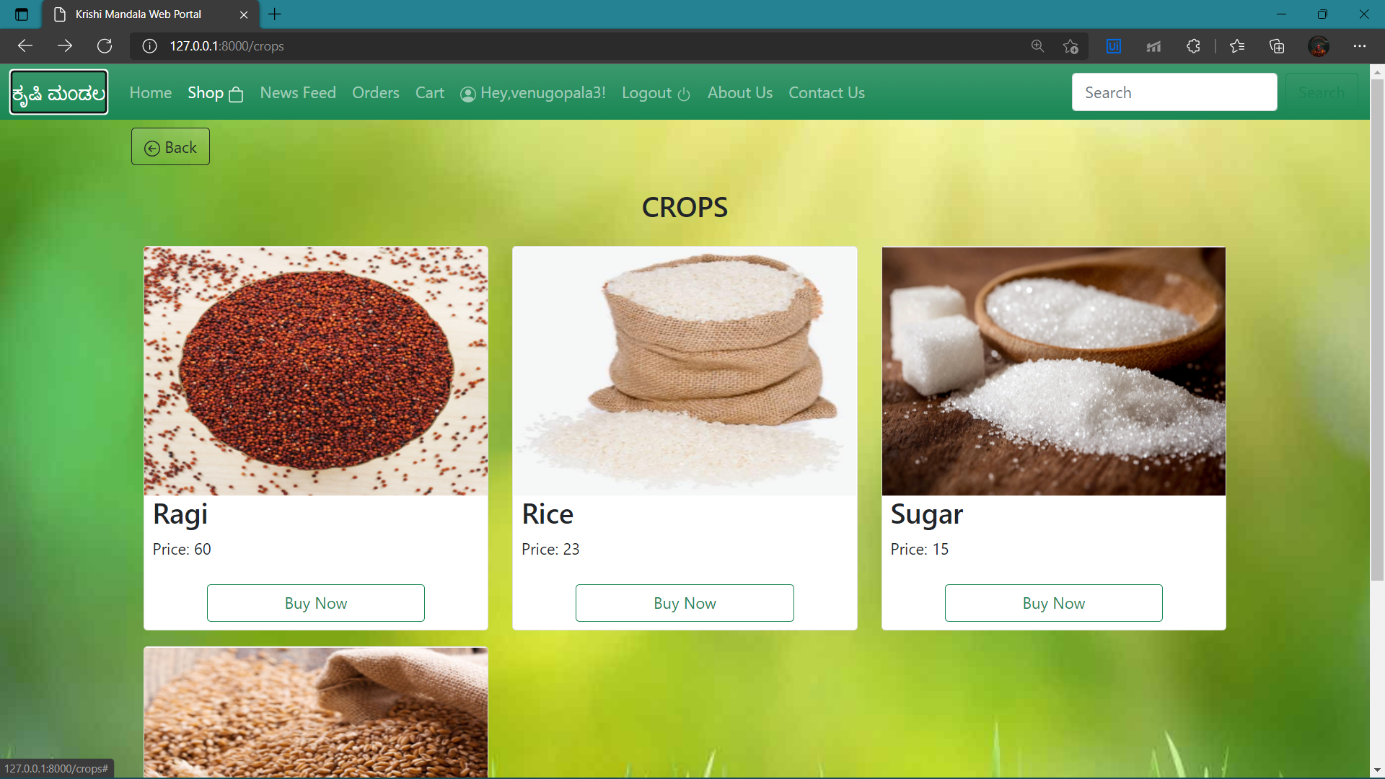

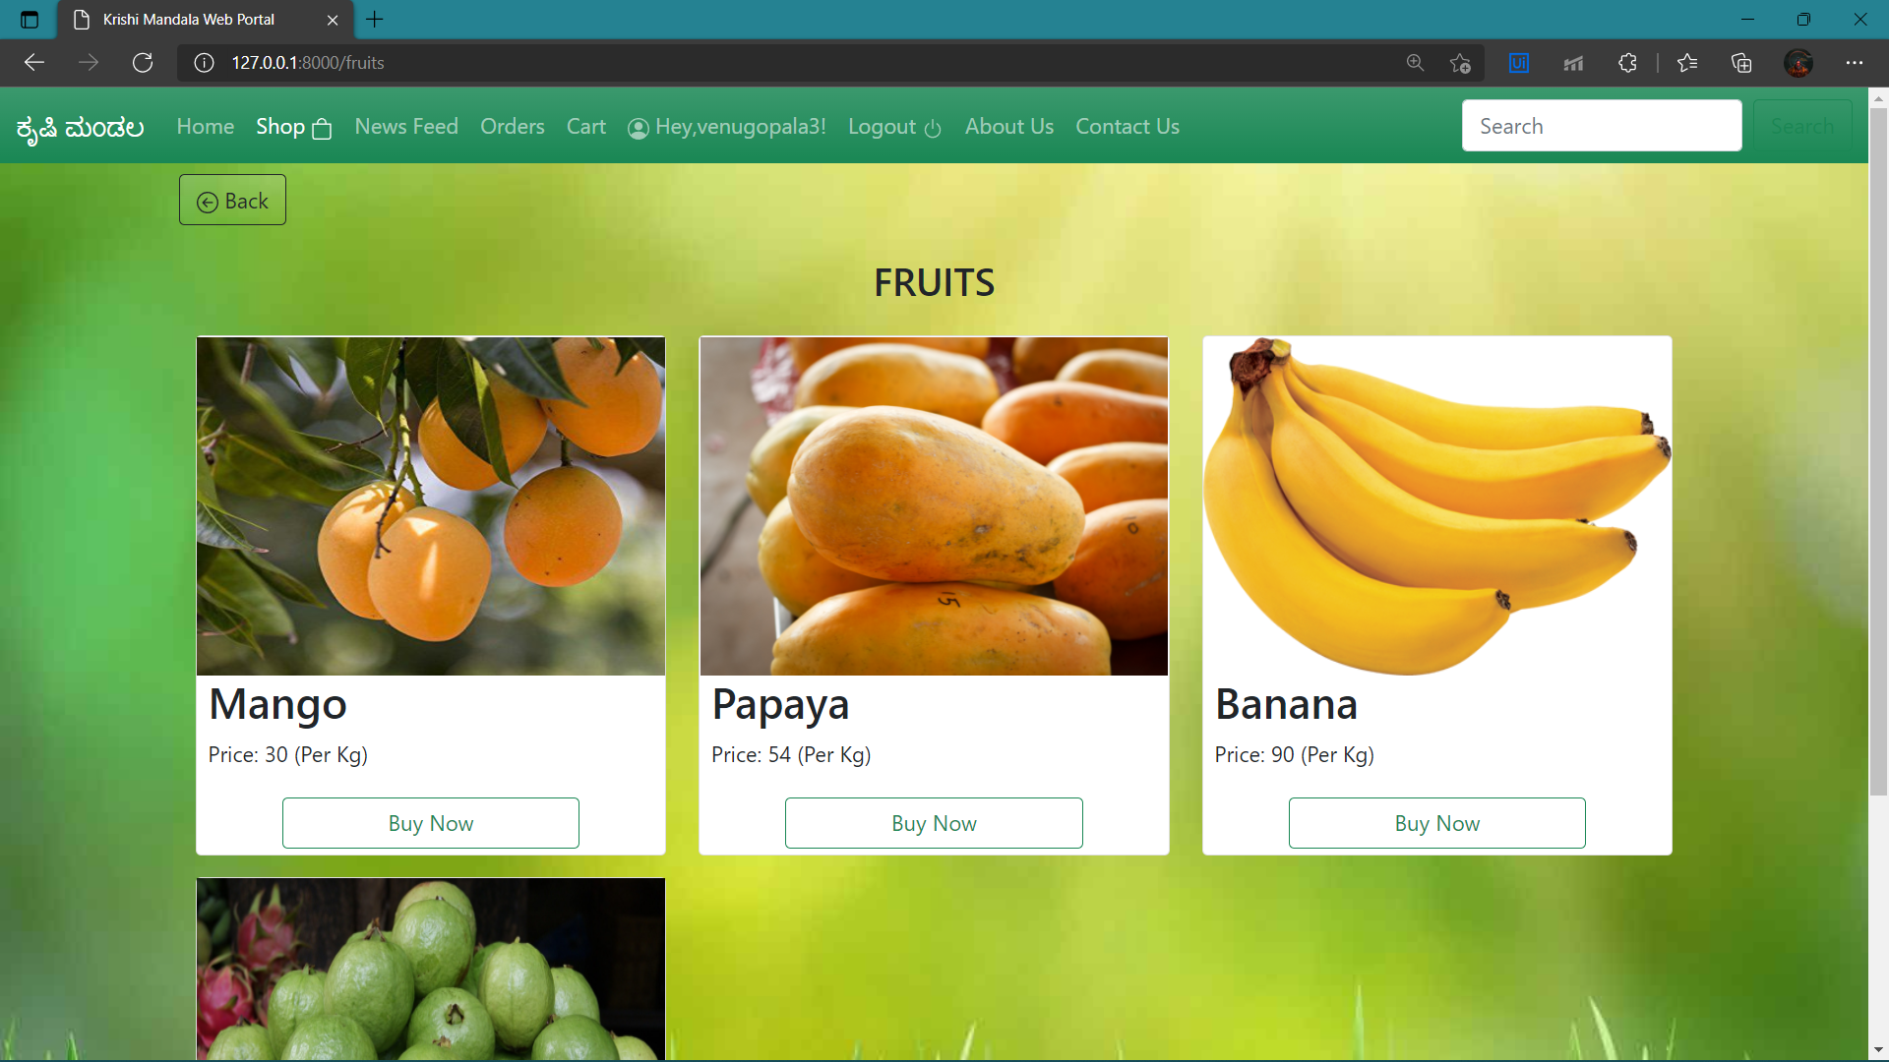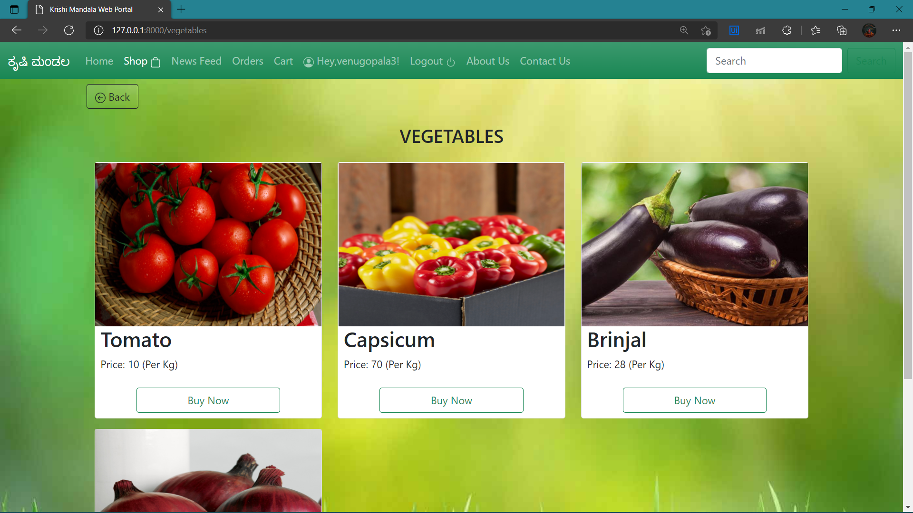 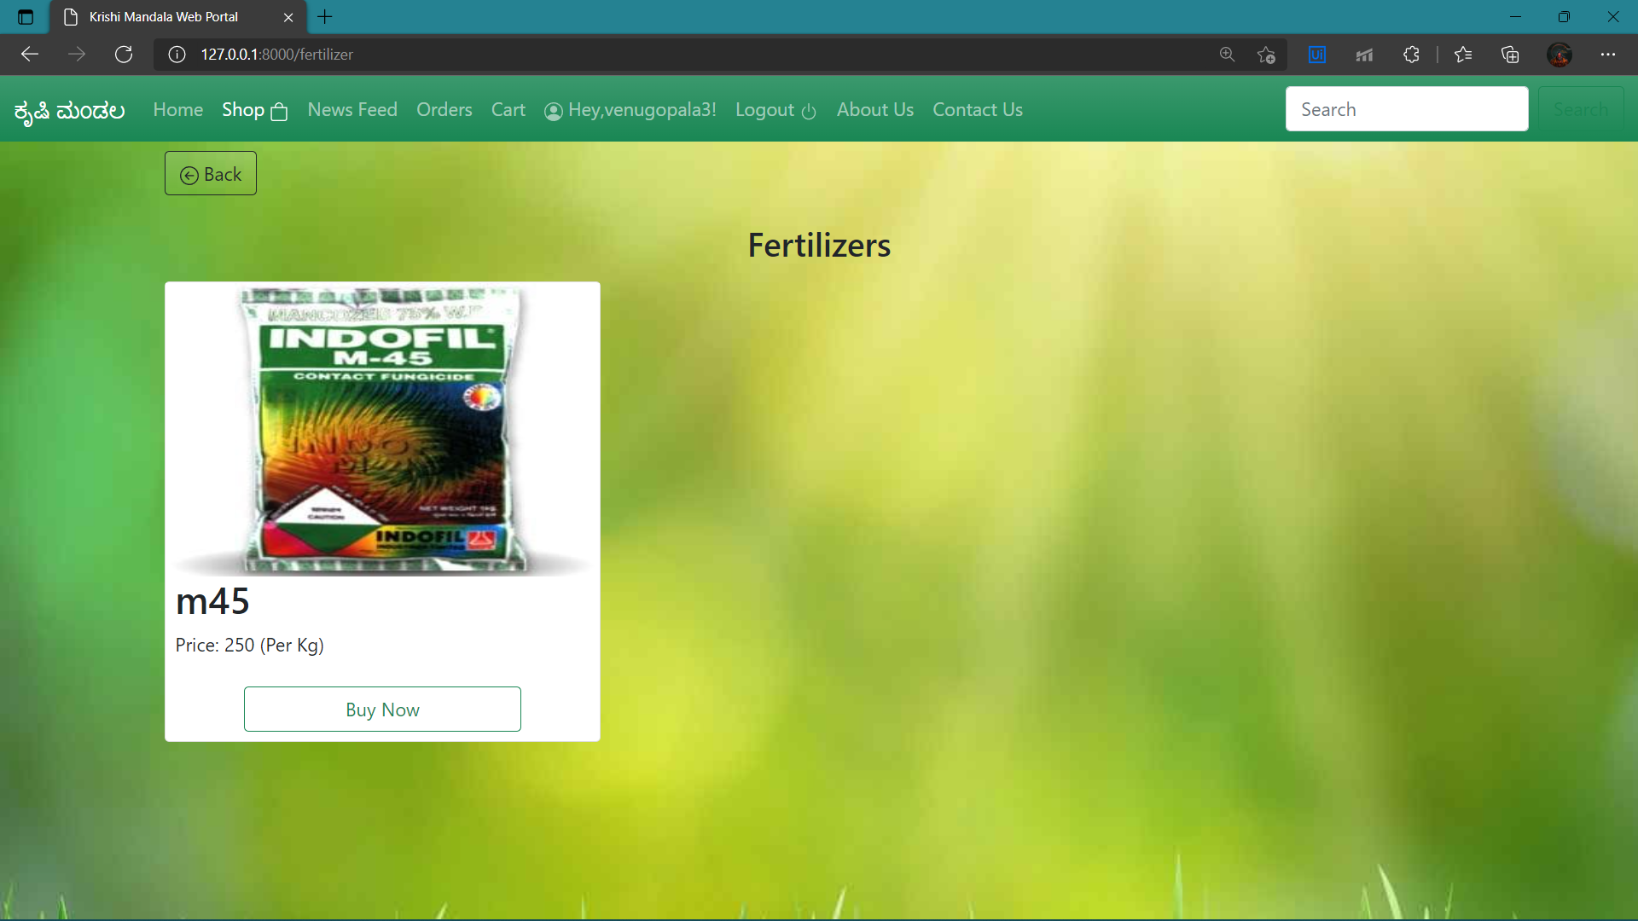 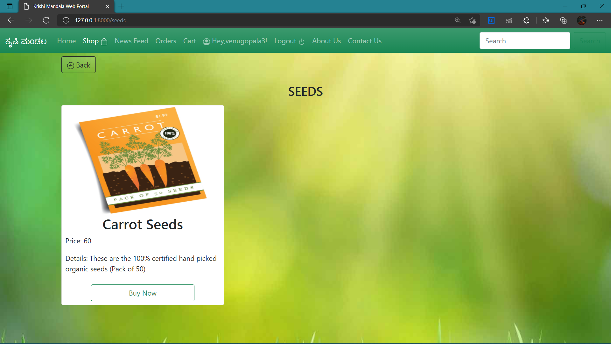 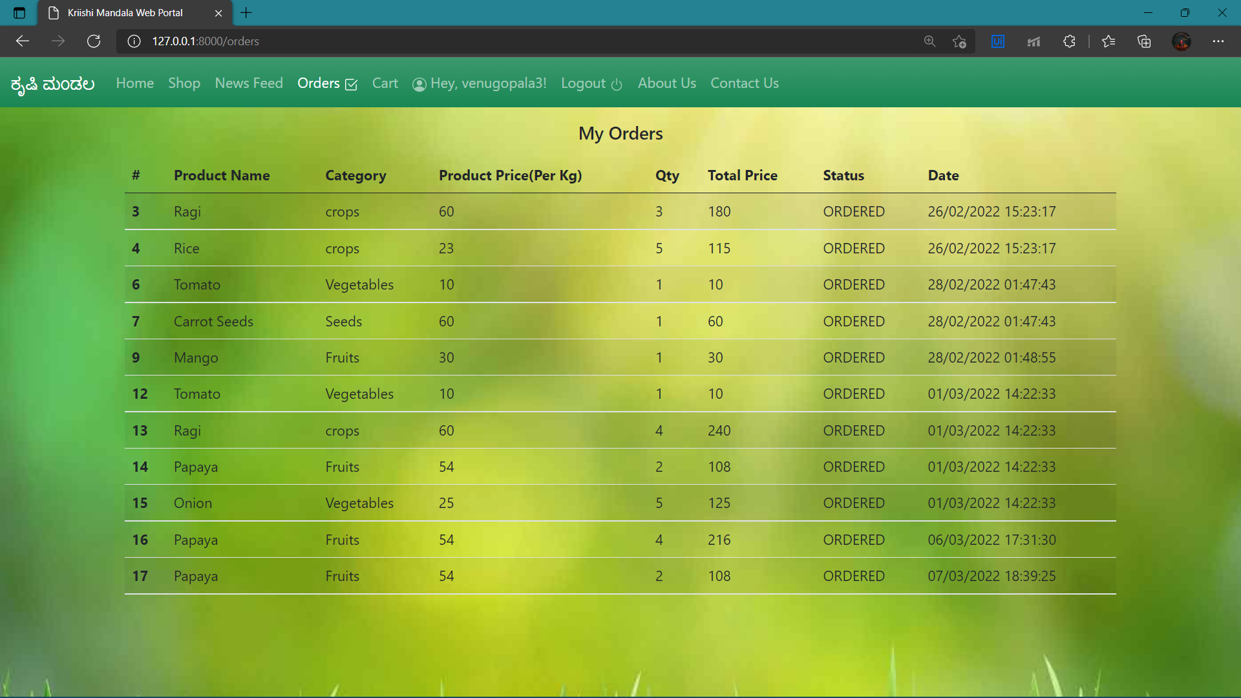 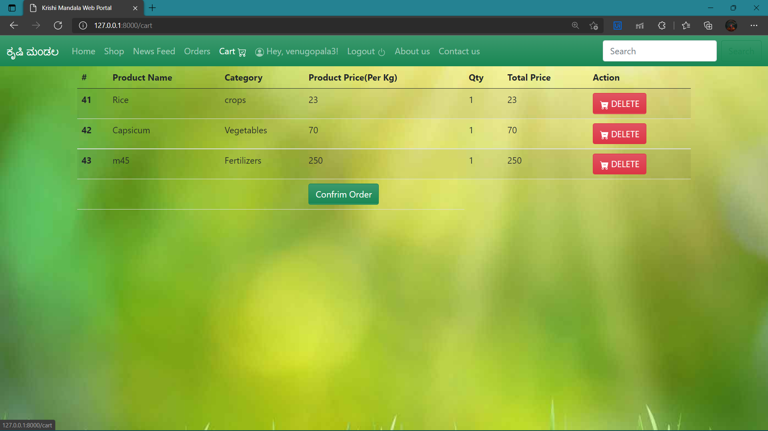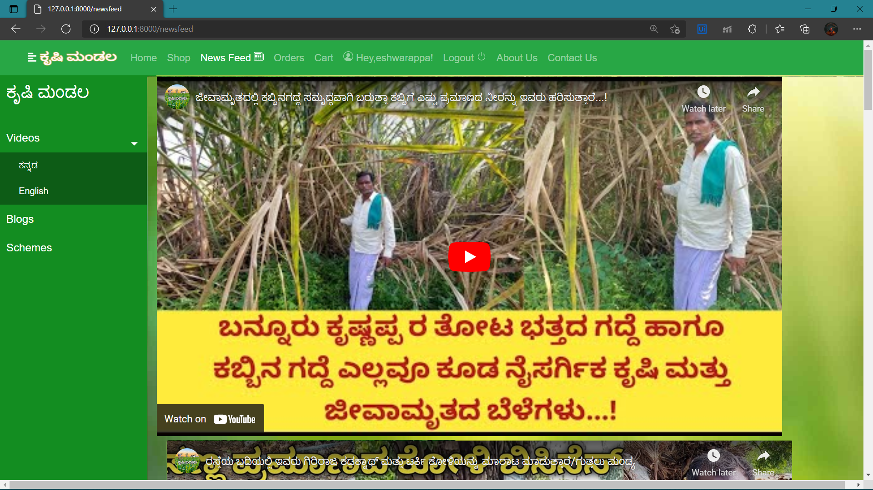

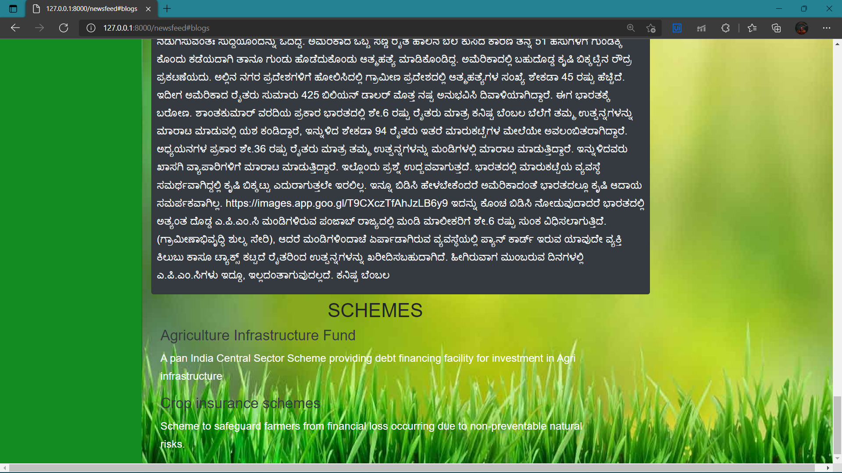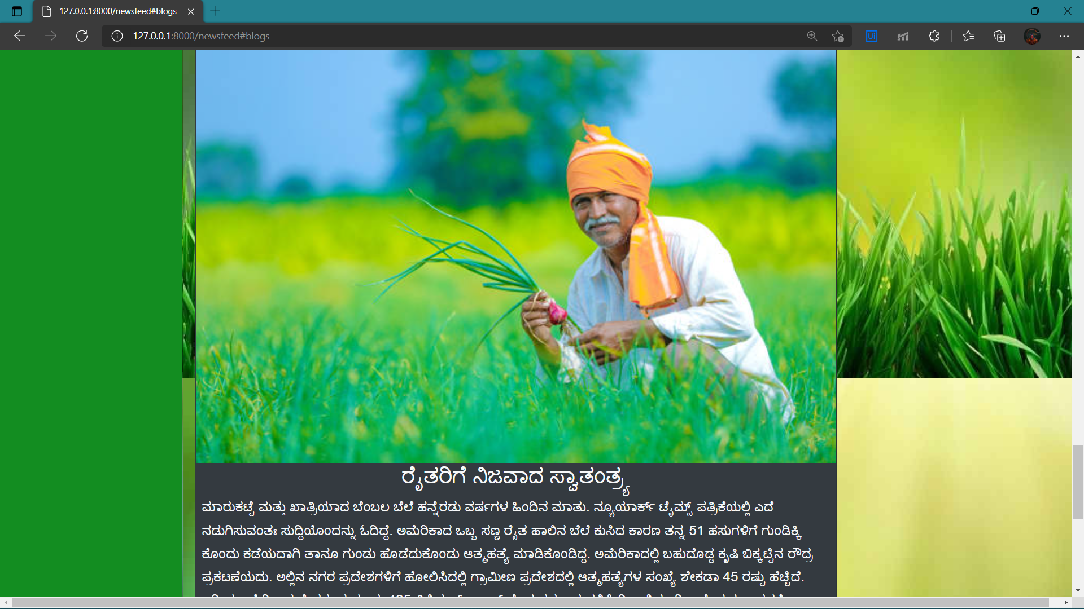

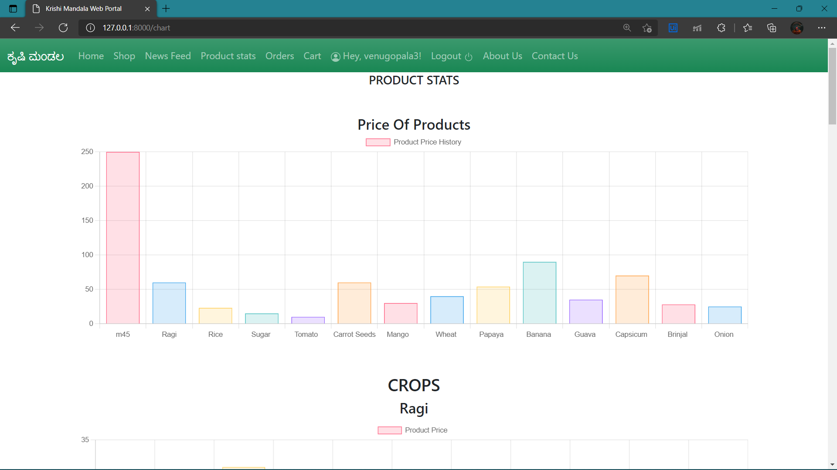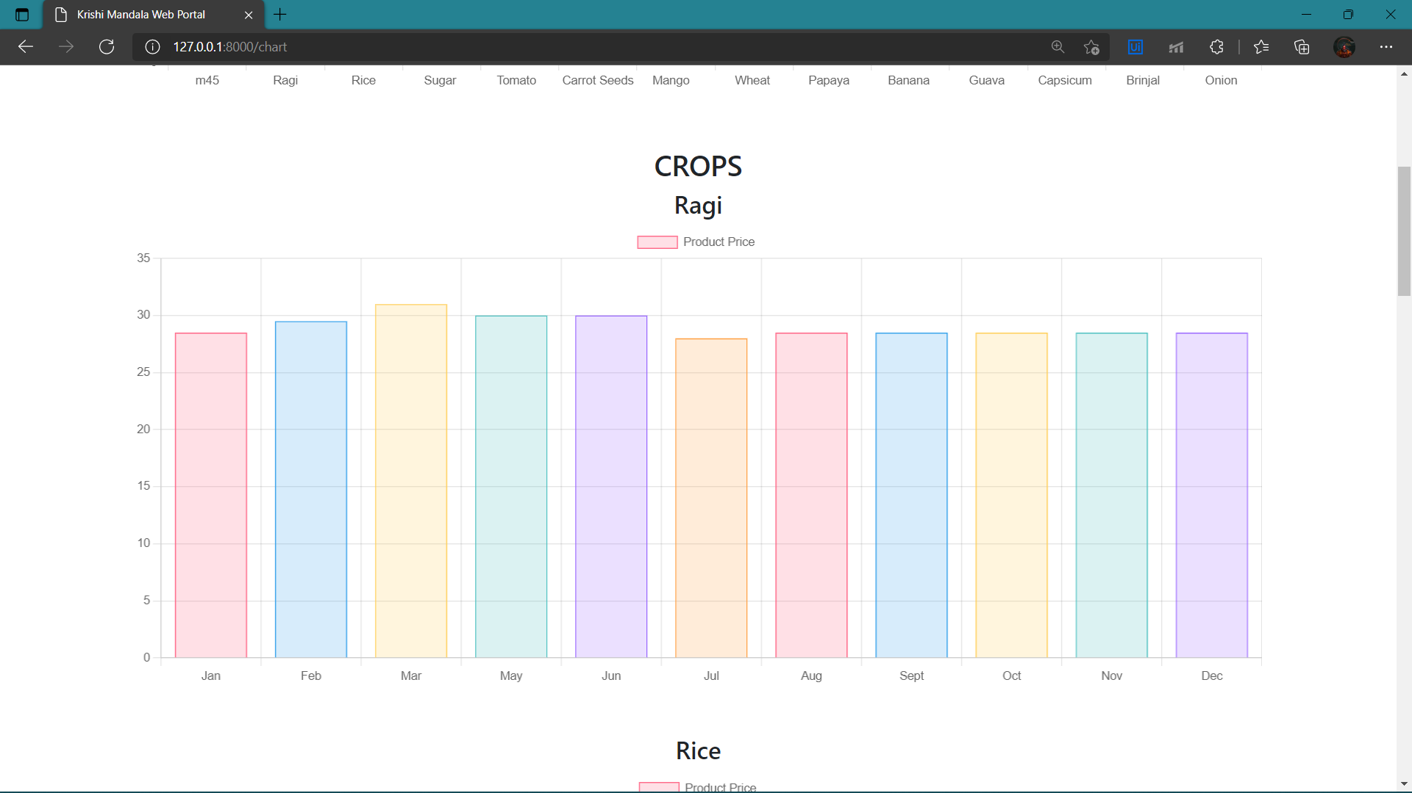

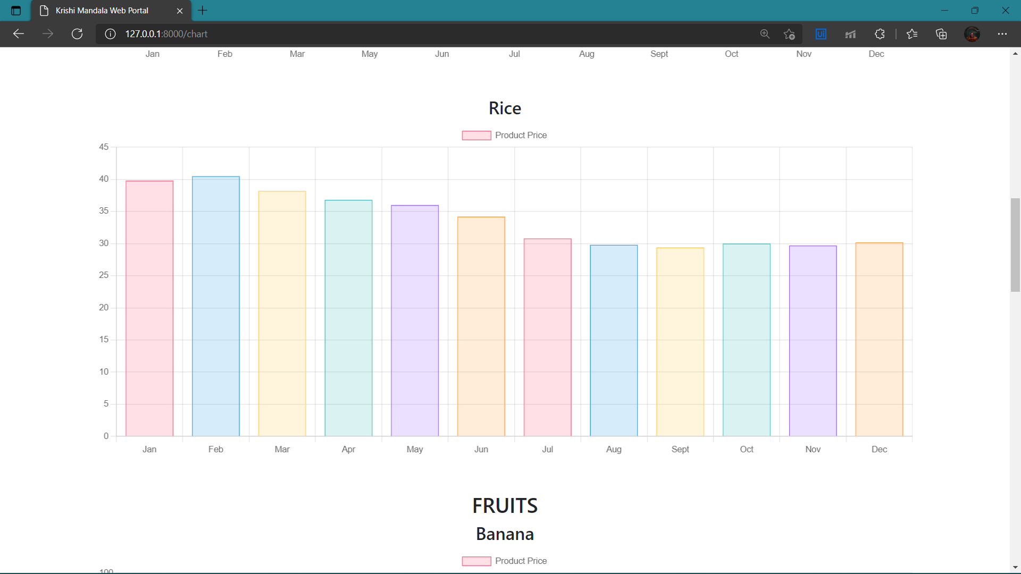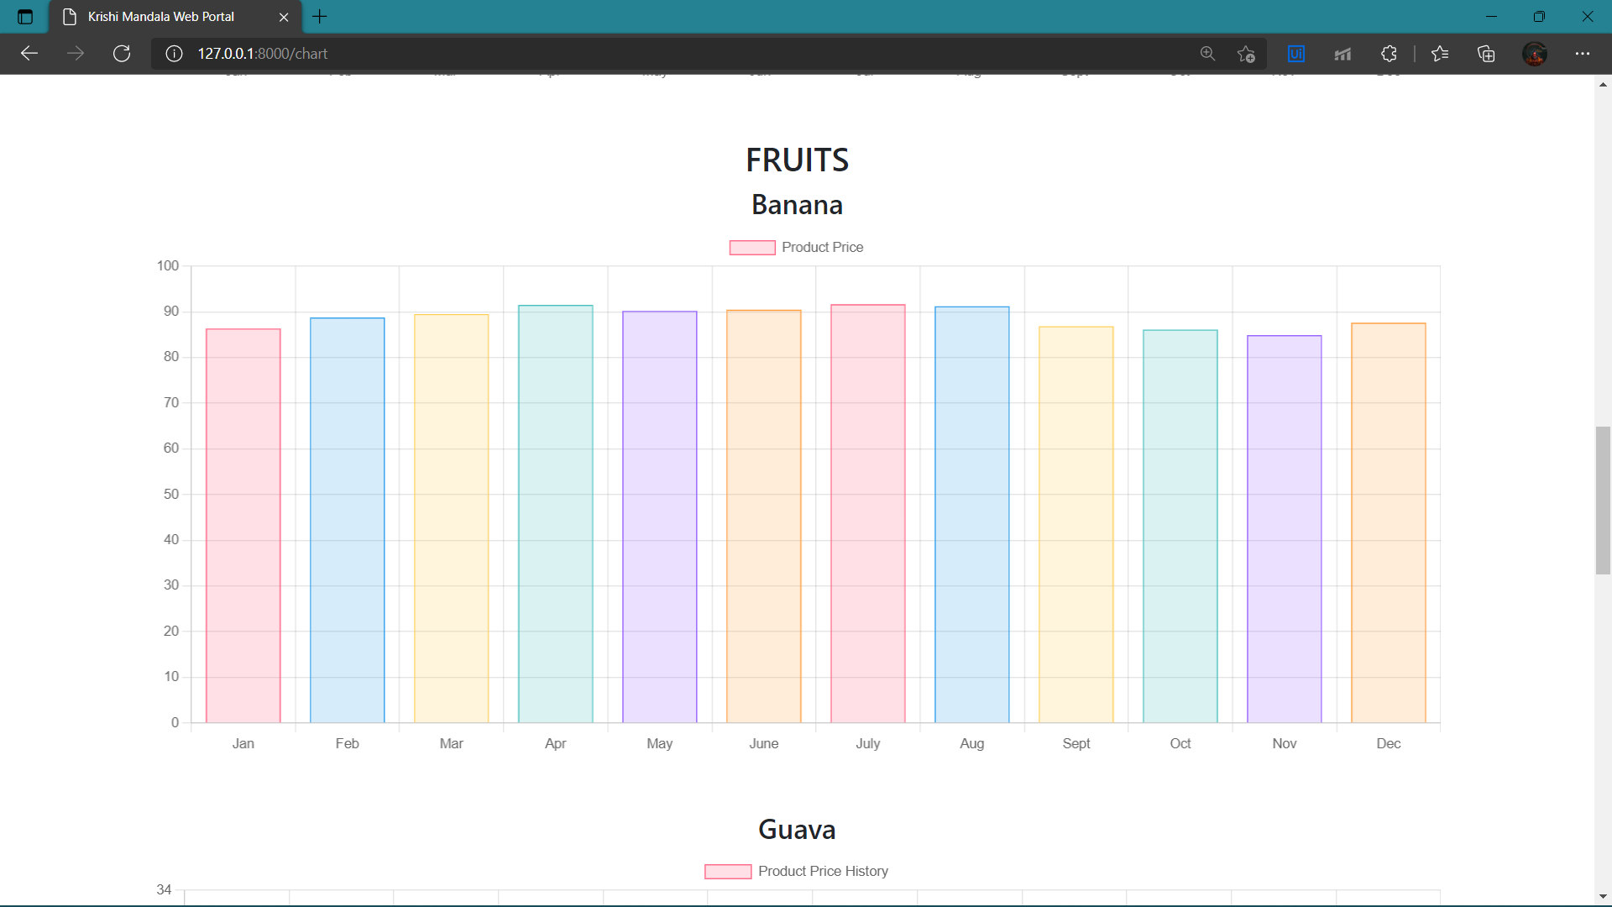

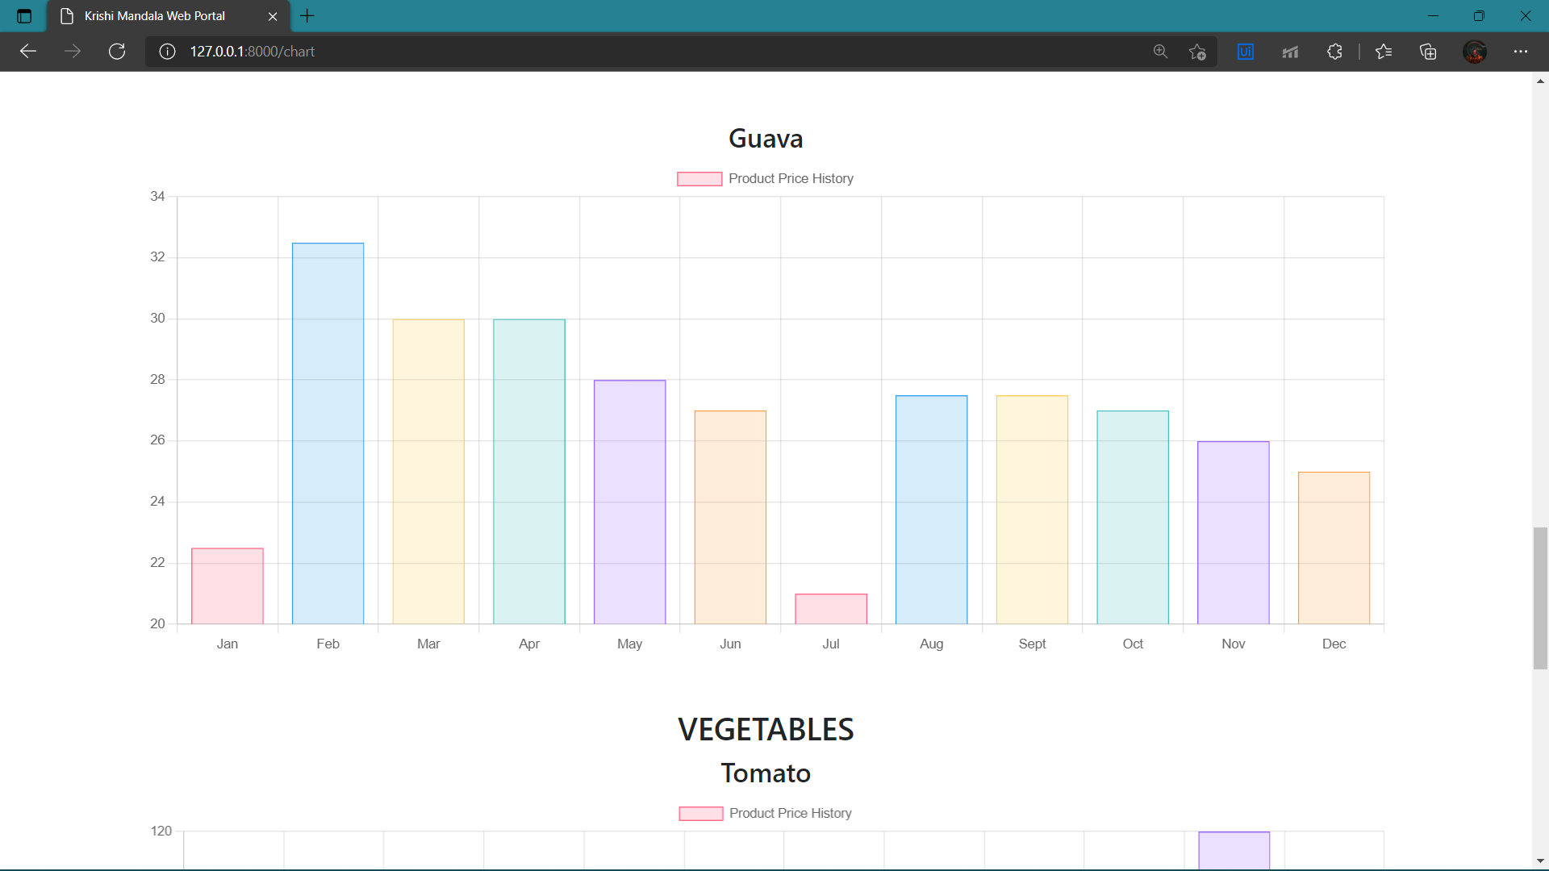

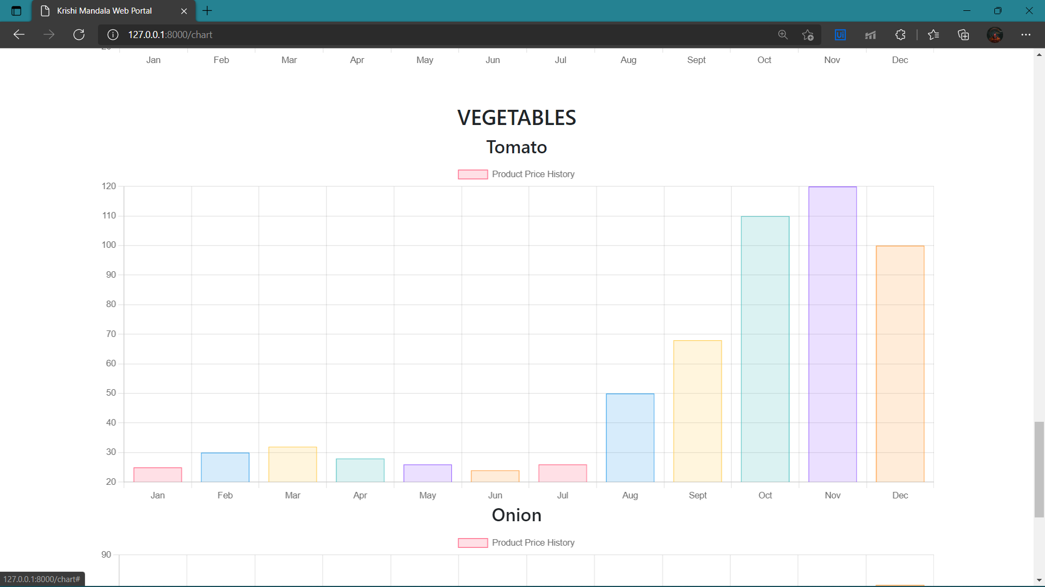

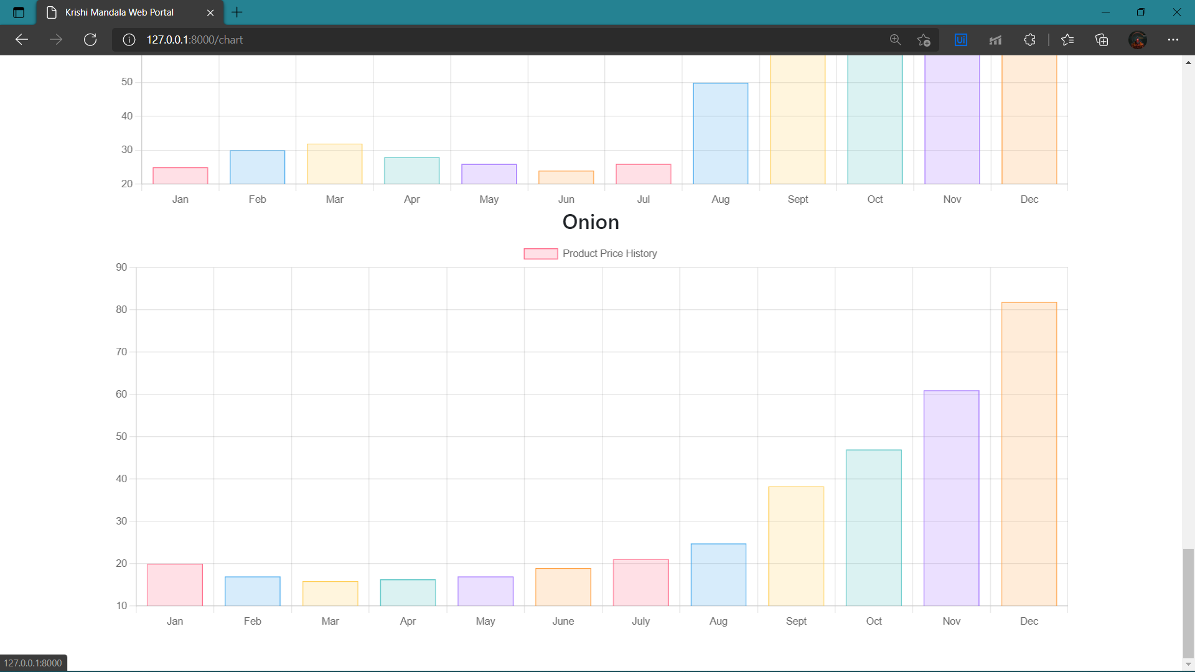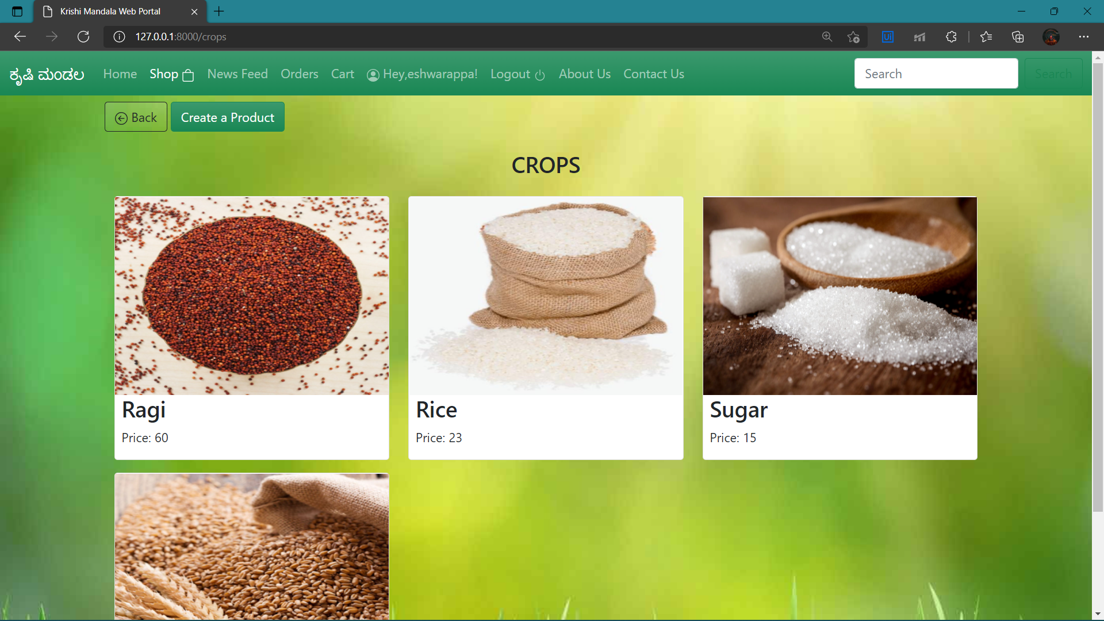

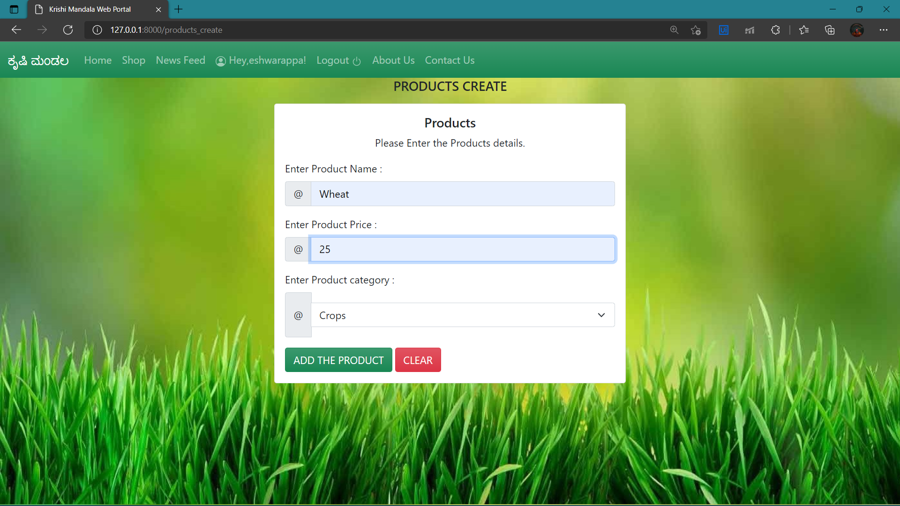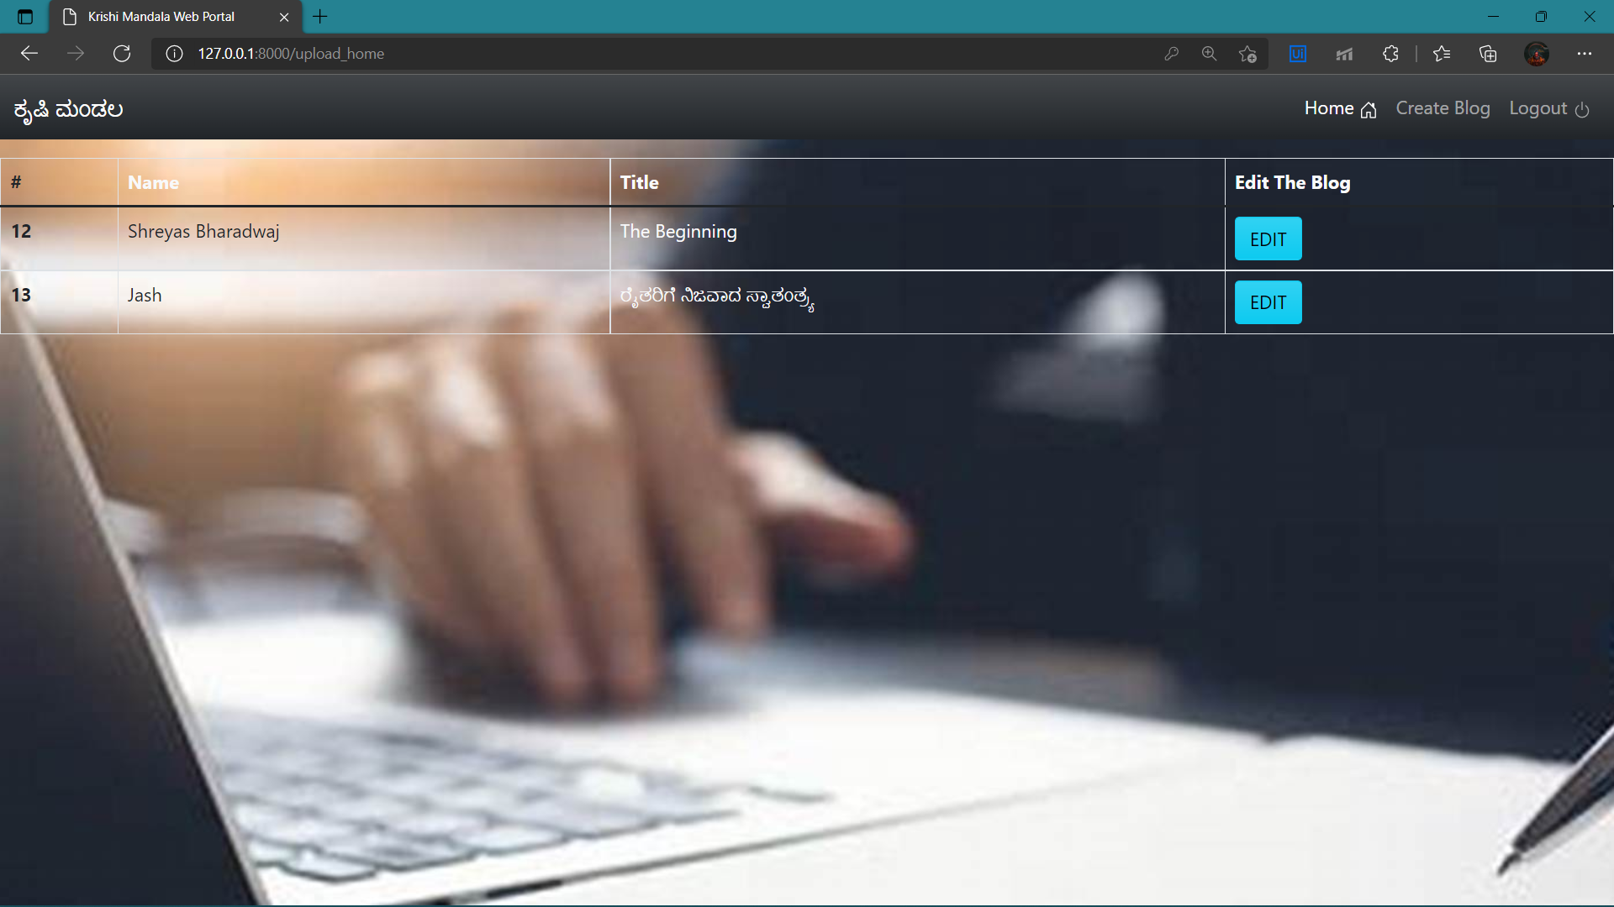

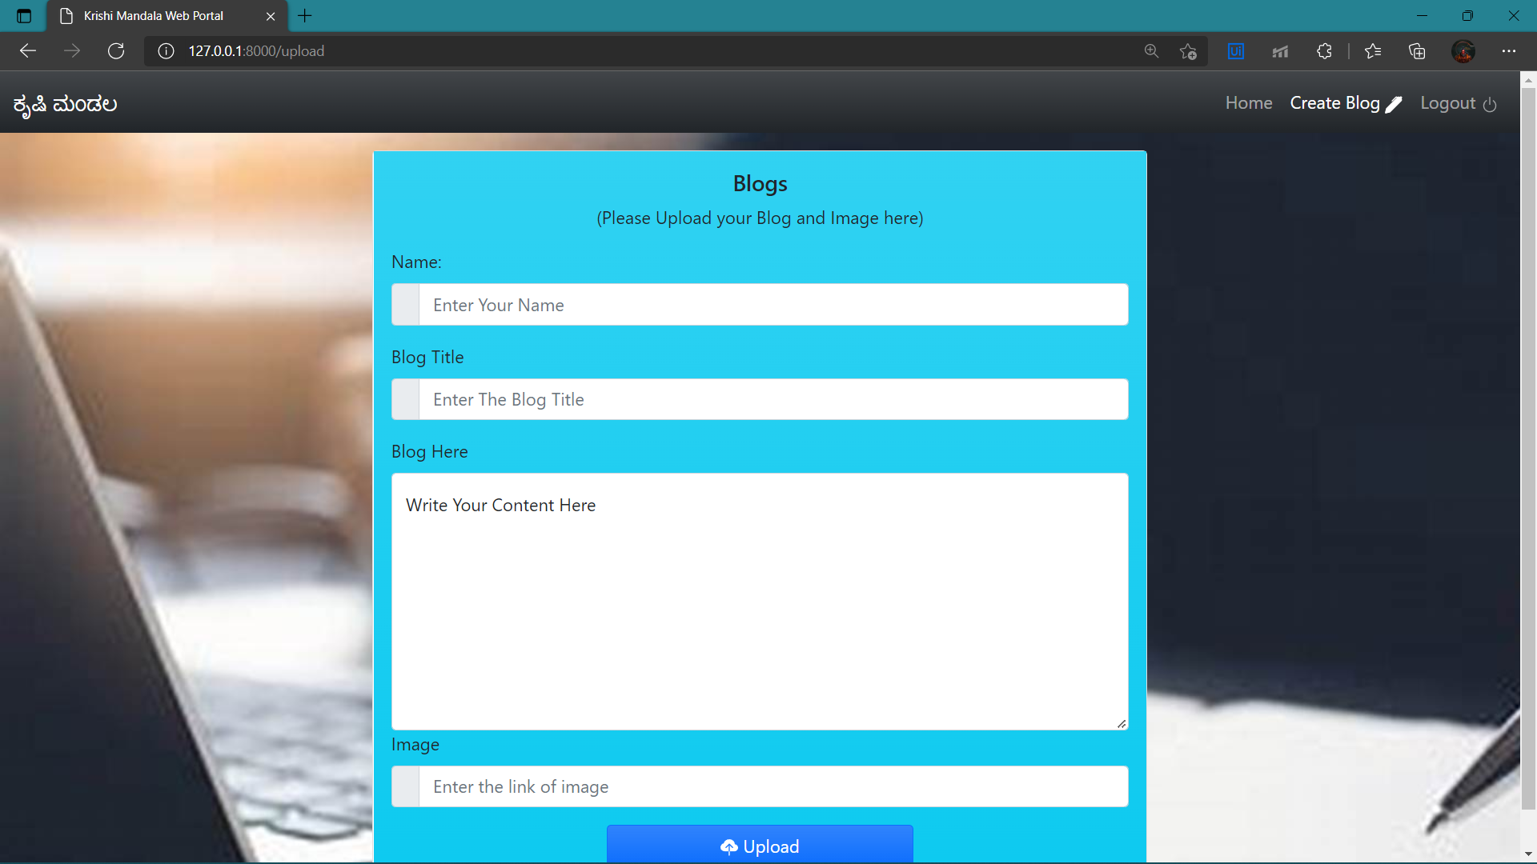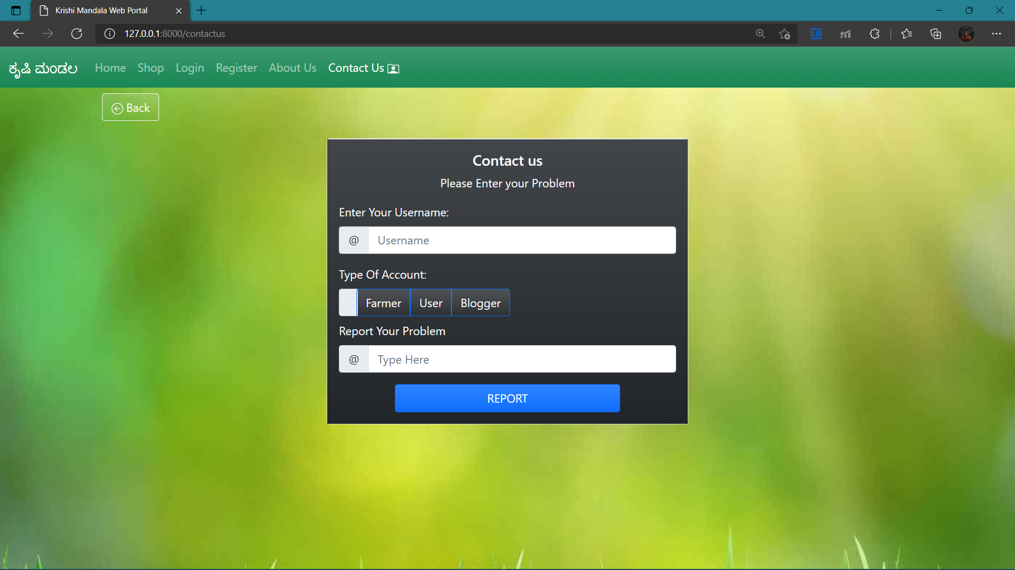

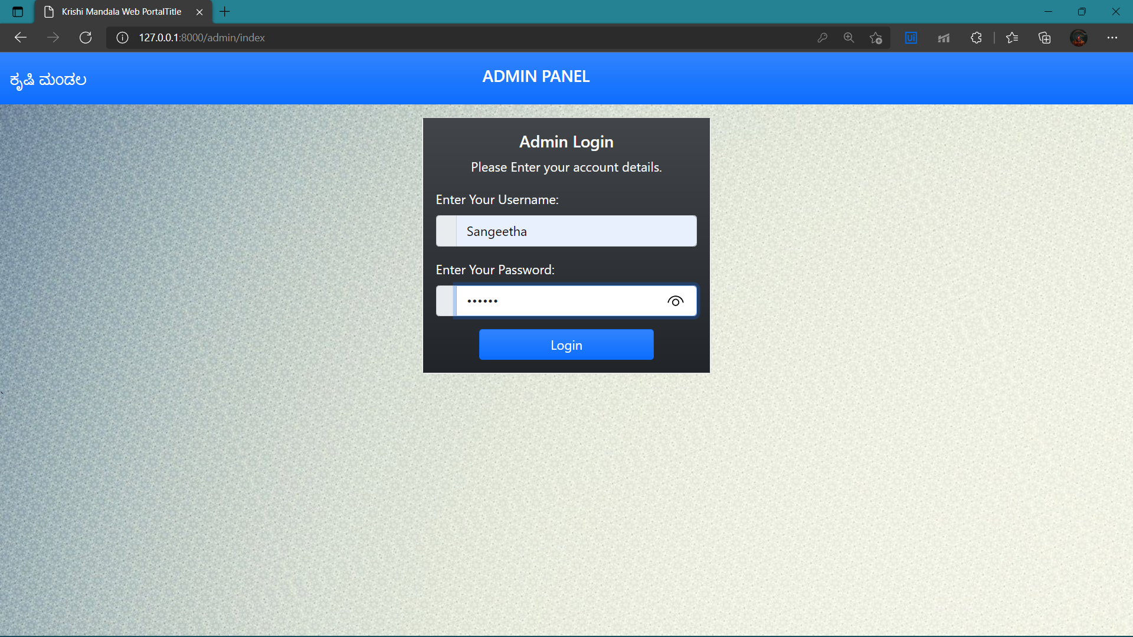

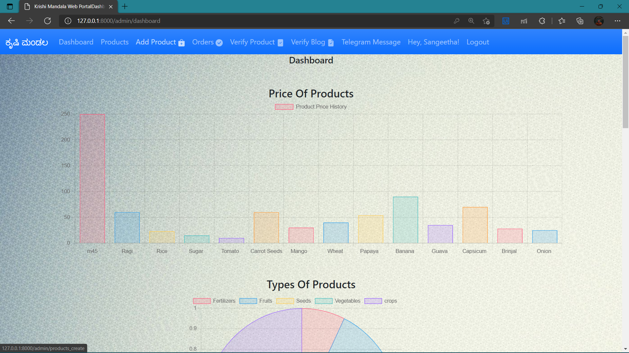

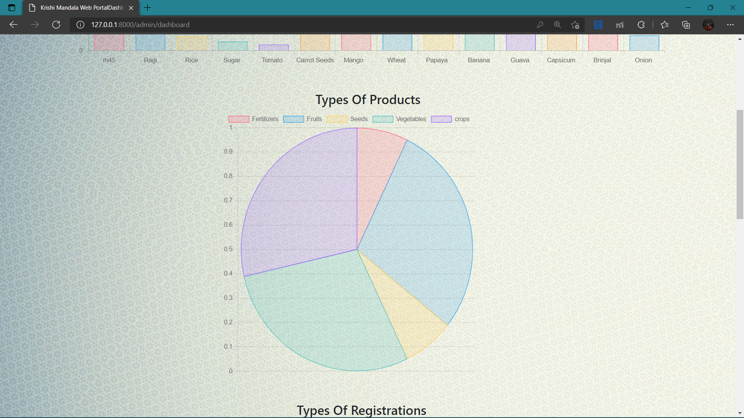

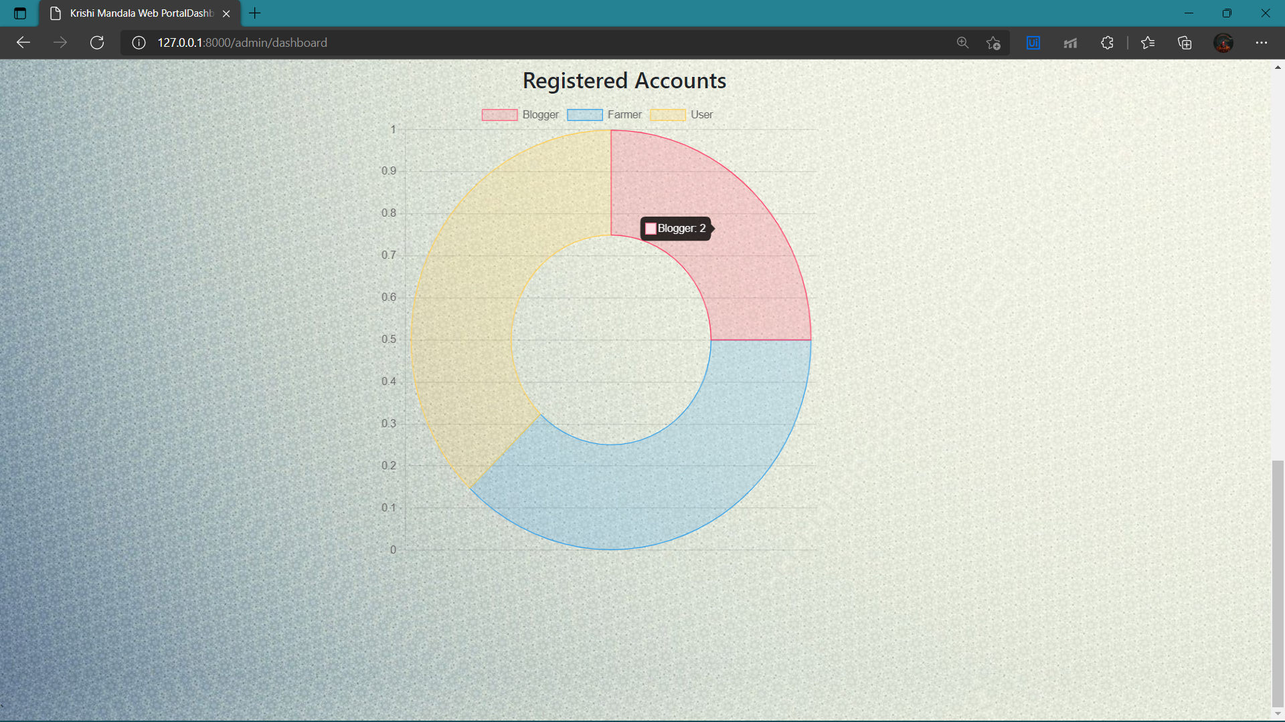

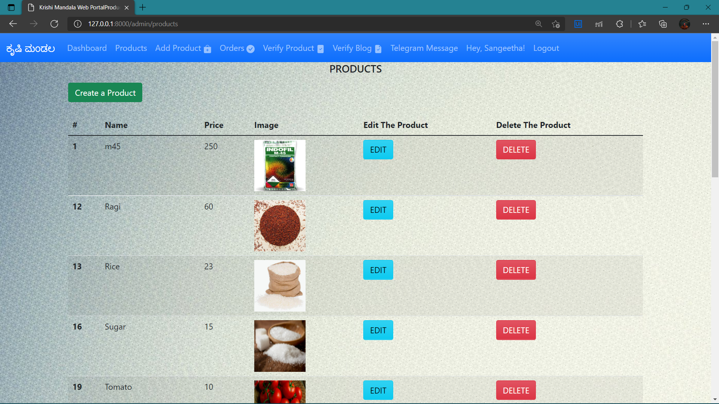

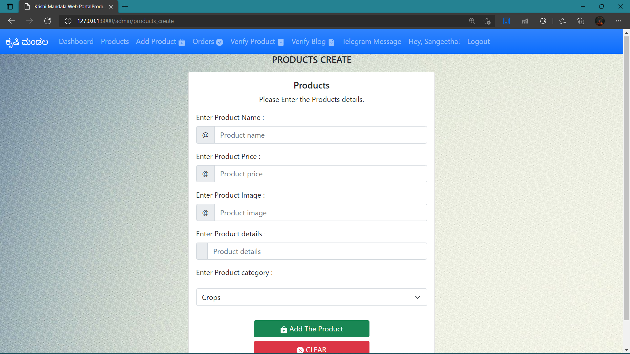

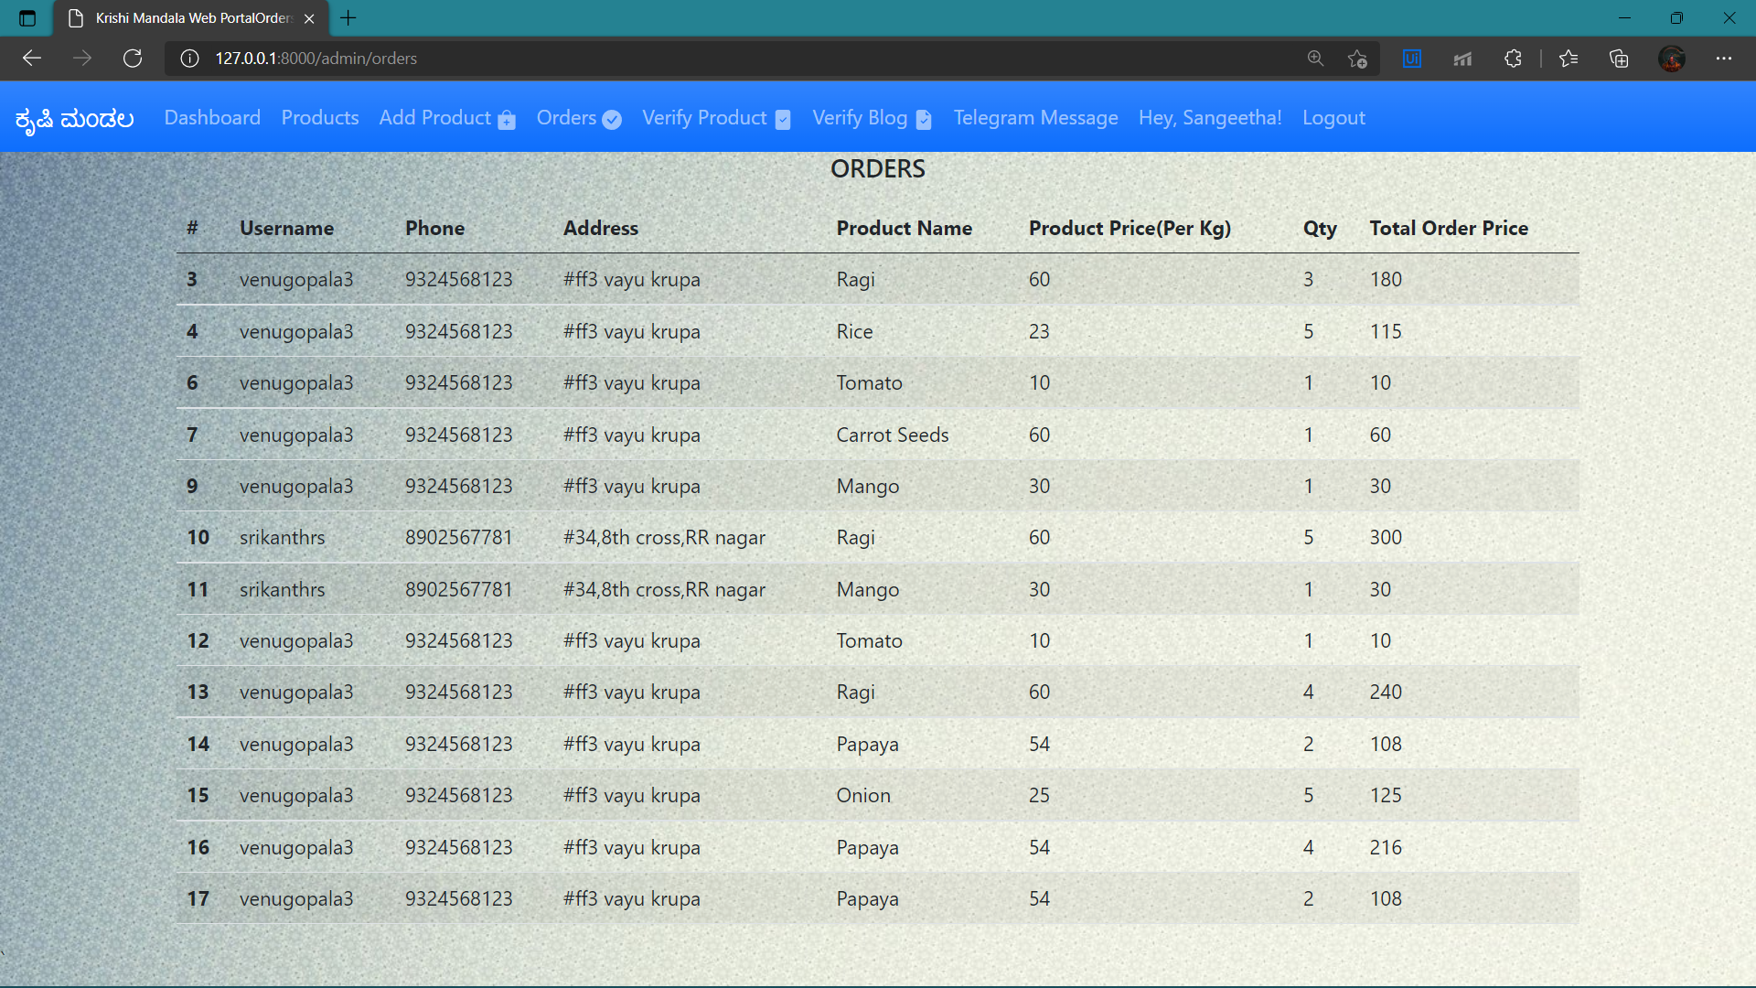

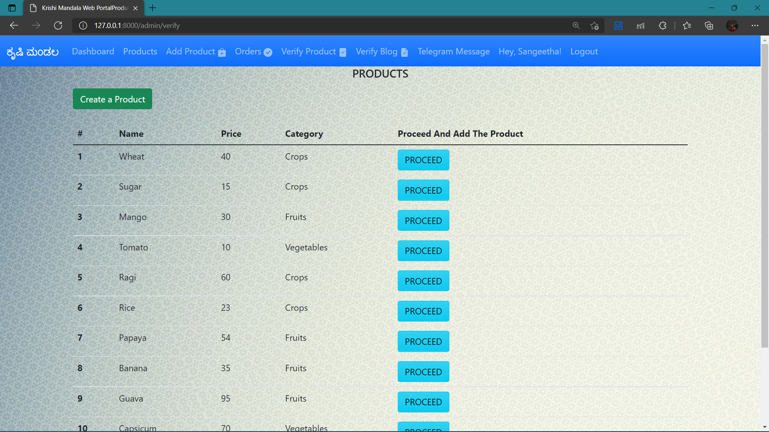

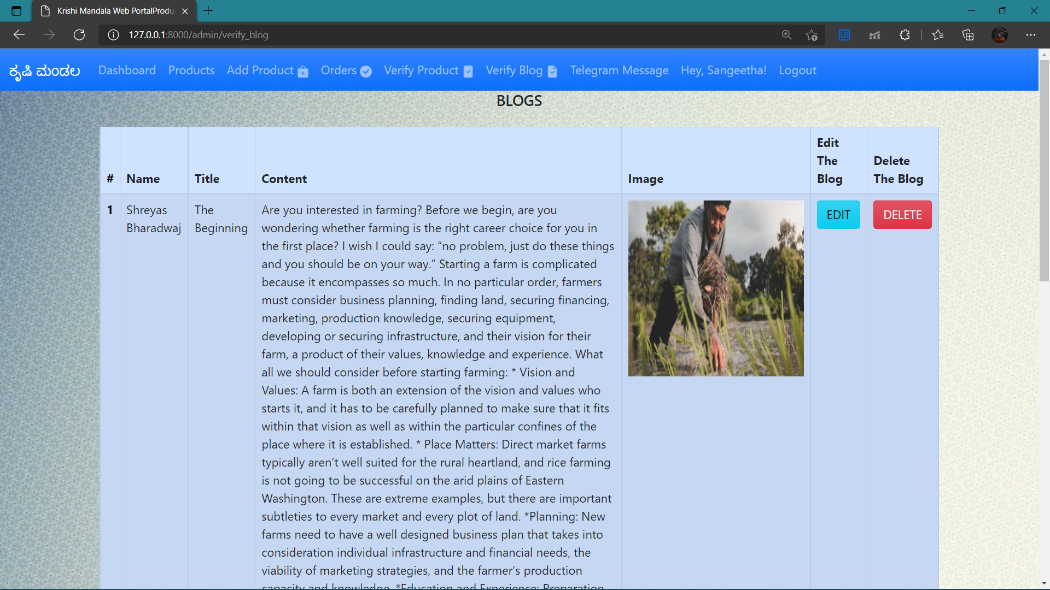

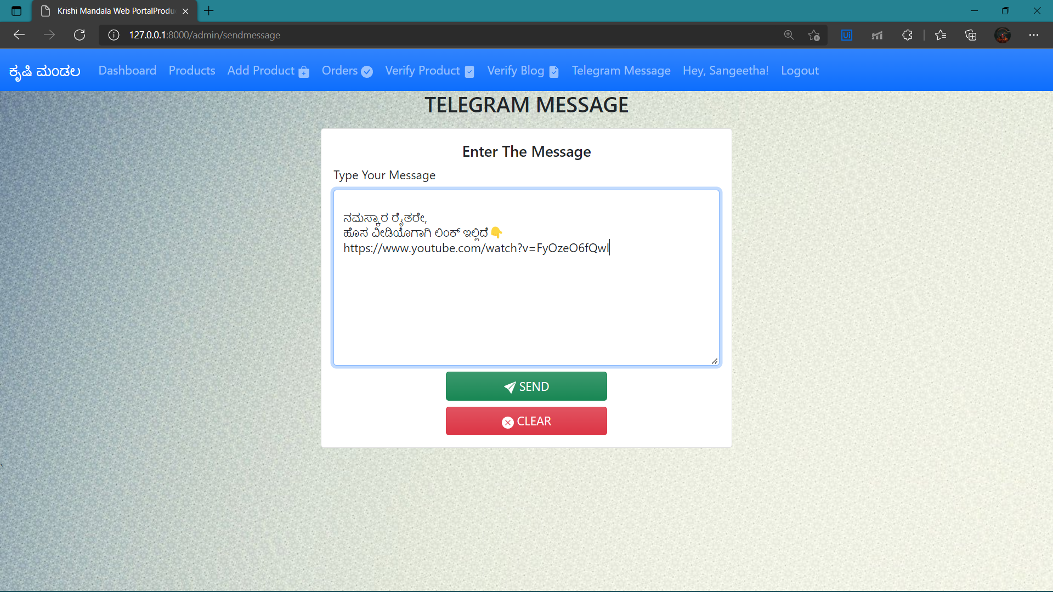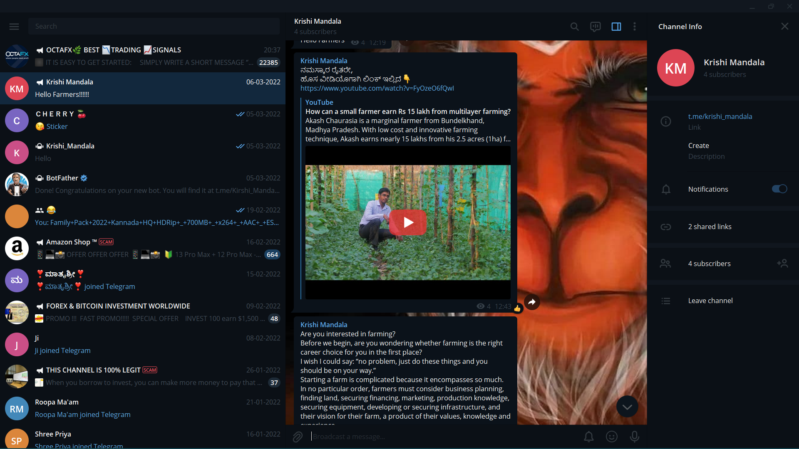

**Front End HTML, CSS and javascript code for Data Visualization:**

{% extends "/admin/base.html" %}

{% block title %}Dashboard{% endblock %}

{% block content %}

<div class="container">

<!-- Added your content -->

<h5 class="text-center">Dashboard</h5>

<div class="row my-5">

<h4 class="text-center">Price Of Products</h4s>

<canvas id="bar_chart" width="800" height="250"></canvas>

<div class="row my-5 ">

<h4 class="text-center">Types Of Products</h4>

<div class="col-md-3"></div>

<canvas id="pie_chart" width="500" height="500"></canvas>

<div class="row my-5">

<h4 class="text-center">Registered Accounts</h4>

<div class="col-md-3"></div>

<canvas id="doughnut_chart" width="500" height="500"></canvas>

</div>

</div>

{% endblock %}

{% block javascript %}

<script>

var chartFarmerTypes,chartFarmerCount;

var chartProductName,chartProductPrice,chartProductTypes,chartProductCounts;

const productNames = (data) => data.map(pname => pname.pname);

const productPrices = (data) => data.map(pname => pname.price);

const productTypes = (data) => data.map(pname => pname.category);

const productCounts = (data) => data.map(pname => pname.count);

const farmerTypes = (data) => data.map(type => type.type);

const farmerCounts = (data) => data.map(type => type.count);

fetch("http://127.0.0.1:8000/products_data").then(res => res.json()).then(data => data)

.then(pnames =>{

chartProductName = productNames(pnames);

chartProductPrice = productPrices(pnames);

var ctx = document.getElementById('bar_chart').getContext('2d');

var myChart = new Chart(ctx, {

type: 'bar',

data: {

labels: chartProductName

datasets: [{

label: 'Product Price History',

data: chartProductPrice,

backgroundColor: [

'rgba(255, 99, 132, 0.2)',

'rgba(54, 162, 235, 0.2)',

'rgba(255, 206, 86, 0.2)',

'rgba(75, 192, 192, 0.2)',

'rgba(153, 102, 255, 0.2)',

'rgba(255, 159, 64, 0.2)'

],

borderColor: [

'rgba(255, 99, 132, 1)',

'rgba(54, 162, 235, 1)',

'rgba(255, 206, 86, 1)',

'rgba(75, 192, 192, 1)',

'rgba(153, 102, 255, 1)',

'rgba(255, 159, 64, 1)'

],

borderWidth: 1

}]

},

options: {

scales: {

y: {

beginAtZero: true

}

}

}

});

});

fetch("http://127.0.0.1:8000/products_types").then(res => res.json()).then(data => data)

.then(pnames =>{

chartProductTypes = productTypes(pnames);

chartProductCounts = productCounts(pnames);

var ctx = document.getElementById('pie_chart').getContext('2d');

var myChart = new Chart(ctx, {

type: 'pie',

data: {

labels: chartProductTypes,

datasets: [{

data: chartProductCounts,

backgroundColor: [

'rgba(255, 99, 132, 0.2)',

'rgba(54, 162, 235, 0.2)',

'rgba(255, 206, 86, 0.2)',

'rgba(75, 192, 192, 0.2)',

'rgba(153, 102, 255, 0.2)',

'rgba(255, 159, 64, 0.2)'

],

borderColor: [

'rgba(255, 99, 132, 1)',

'rgba(54, 162, 235, 1)',

'rgba(255, 206, 86, 1)',

'rgba(75, 192, 192, 1)',

'rgba(153, 102, 255, 1)',

'rgba(255, 159, 64, 1)'

],

borderWidth: 1

}]

},

options: {

responsive: false,

scales: {

y: {

beginAtZero: true

}

}

}

});

});

fetch("http://127.0.0.1:8000/farmer_types").then(res => res.json()).then(data => data)

.then(type =>{

chartFarmerTypes = farmerTypes(type);

chartFarmerCount = farmerCounts(type);

var ctx = document.getElementById('doughnut_chart').getContext('2d');

var myChart = new Chart(ctx, {

type: 'doughnut',

data: {

labels: chartFarmerTypes,

datasets: [{

data: chartFarmerCount,

backgroundColor: [

'rgba(255, 99, 132, 0.2)',

'rgba(54, 162, 235, 0.2)',

'rgba(255, 206, 86, 0.2)',

'rgba(75, 192, 192, 0.2)',

'rgba(153, 102, 255, 0.2)',

'rgba(255, 159, 64, 0.2)'

],

borderColor: [

'rgba(255, 99, 132, 1)',

'rgba(54, 162, 235, 1)',

'rgba(255, 206, 86, 1)',

'rgba(75, 192, 192, 1)',

'rgba(153, 102, 255, 1)',

'rgba(255, 159, 64, 1)'

],

borderWidth: 1

}]

},

options: {

responsive: false,

scales: {

y: {

beginAtZero: true

}

}

}

});

});

var chartProductMonth,chartProductPrice;

const productMonths = (data) => data.map(month => month.month);

const productPricess = (data) => data.map(month => month.price);

fetch("http://127.0.0.1:8000/products_chart").then(res => res.json()).then(data => data)

.then(months =>{

chartProductMonth = productMonths(months);

chartProductPrice = productPricess(months);

var ctx = document.getElementById('line_chart').getContext('2d');

var myChart = new Chart(ctx, {

type: 'line',

data: {

labels: chartProductMonth,

datasets: [{

label: 'Product Price History',

data: chartProductPrice,

backgroundColor: [

'rgba(255, 99, 132, 0.2)',

'rgba(54, 162, 235, 0.2)',

'rgba(255, 206, 86, 0.2)',

'rgba(75, 192, 192, 0.2)',

'rgba(153, 102, 255, 0.2)',

'rgba(255, 159, 64, 0.2)'

],

borderColor: [

'rgba(255, 99, 132, 1)',

'rgba(54, 162, 235, 1)',

'rgba(255, 206, 86, 1)',

'rgba(75, 192, 192, 1)',

'rgba(153, 102, 255, 1)',

'rgba(255, 159, 64, 1)'

],

borderWidth: 1

}]

},

options: {

scales: {

y: {

beginAtZero: true

}

}

}

});

});

</script>

{% endblock %}

**Front End HTML, CSS and Javascript code for verifying and editing blogs:**

{% extends "/admin/base.html" %}

{% block title %}Products Create{% endblock %}

{% block content %}

<div class="container">

<!-- Added your content -->

<h5 class="text-center">PRODUCTS CREATE</h5>

<form class="my-3" method="POST" action="/admin/products_create">

<div class="row">

<div class="col-md-3"></div>

<div class="col-md-6">

<div class="card" >

<div class="card-body">

<h5 class="card-title text-center">Products</h5>

<p class="card-text text-center">Edit the Products details.</p>

{% for product in products %}

<label for="pname" class="form-label">Edit Product Name :</label>

<div class="input-group mb-3">

<span class="input-group-text" id="pname">@</span>

<input type="text" id="pname" name="pname" class="form-control" placeholder="Product name"

value="{{product.pname}} " aria-label="pname" aria-describedby="basic-addon1" required>

</div>

<label for="price" class="form-label">Edit Product Price :</label>

<div class="input-group mb-3">

<span class="input-group-text" id="price">@</span>

<input type="text" id="price" name="price" class="form-control" placeholder="Product price"

value="{{product.price}} " aria-label="price" aria-describedby="basic-addon1" required>

</div>

<label for="image" class="form-label">Edit Product Image :</label>

<div class="input-group mb-3">

<span class="input-group-text" id="image">@</span>

<input type="text" id="image" name="image" class="form-control" placeholder="Product image"

aria-label="image" aria-describedby="basic-addon1" required>

</div>

<label for="details" class="form-label">Edit Product Details :</label>

<div class="input-group mb-3">

<span class="input-group-text" id="details"></span>

<input type="text" id="details" name="details" class="form-control" placeholder="Product details"

aria-label="details" aria-describedby="basic-addon1" required>

</div>

<label for="details" class="form-label">Edit Product Category :</label>

<div class="input-group mb-3">

<span class="input-group-text" id="details"></span>

<input type="text" id="details" value="{{product.category}}" name="category" class="form-control" placeholder="Product details"

aria-label="details" aria-describedby="basic-addon1" required>

</div>

<div class="d-grid gap-2 col-5 mx-auto">

<button class="btn btn-success bg-gradient" type="submit">Add The Product</button>

</div>

{% endfor %}

</div>

</div>

</div>

</form>

</div>

{% endblock %}

{% block javascript %}

<script type="text/javascript">

</script>

{% endblock %}

**Future Enhancement**

Connecting with every individual farmer is the goal of the project. Sending updated information about agriculture to farmers through normal messages which can be accessed by keypad mobile is our further goal. As of now to achieve that we have integrated telegram which is free of cost and also to implement dynamic data visualization to predict crops price, to predict in which weather conditions it can be grown in.

**CONCLUSION**

This project is developed with python programming language. The project completely computerizes the existing system.

The agricultural sector is of vital importance for the region. Farmers are the backbone of our country. A village makes no progress if its farmers are not modern. In addition to the farmers contribute almost 17% of the Indian economy. That is the maximum of all. They are the ones who provide us all the food that we eat. As a result, the entire population of the country depends upon farmers.

“So let us help farmers today, they will help us for the rest of our life.”

-Sangeetha S

We would also like to say that it was very overwhelming to work with python.

Thank you!

Bibliography:

[www.getbootstrap.com](http://www.getbootstrap.com)

[www.w3schools.com](http://www.w3schools.com)

[www.stackoverflow.com](http://www.stackoverflow.com)

<https://youtube.com/channel/UC0VTxSFkSENubVt9ErwgUaQ>